

|  |  |  |  |
| --- | --- | --- | --- |
| Course Code | : | SWE306 | |
| Course Name | : | Programming elective Ⅱ | |
| Lecturer | : | Dr. Xiao Han | |
| Academic Session | : | 2018/09 | |
| Assessment Title | : | Web Project | |
| Submission Due Date | : | 11/01/2019 | |
| Prepared by |  |  | |
| : | Student ID | Student Name |
|  | SWE1609022 | XIE YIDAN |
|  |  | DMT1609016 | ZENG LIJIE |
|  |  | SWE1609013 | LING ZIQI |
| Date Received | : |  | |
|  |  |  | |
| Feedback from Lecturer: | | | |

**Own Work Declaration**

I/We hereby understand my/our work would be checked for plagiarism or other misconduct, and the softcopy would be saved for future comparison(s).

I/We hereby confirm that all the references or sources of citations have been correctly listed or presented and I/we clearly understand the serious consequence caused by any intentional or unintentional misconduct.

This work is not made on any work of other students (past or present), and it has not been submitted to any other courses or institutions before.

Signature: XIE YIDAN, ZENG LIJIE, LING ZIQI

Date: 2019.01.13

**XMUM LIFE**

**（Xiamen University Malaysia Second Hand Exchange Web)**

1. **Introduction**

The website we made is a second-hand exchange website. We named this website as XMUM LIFE. The main purpose of our website is to provide convenient services about second-hand trading for teachers and students of Xiamen University Malaysia. This website is intended as a platform for them to pick, collect and publish idle items, moreover, they can communicate via message in the website. In short, we hope this website will make students and teachers of Xiamen University Malaysia publish and purchase some idle items more easily.

This website is mainly to provide a platform on which seller can publish idle item. After that, the users can browse the product information on the website. If they are interested in one product, they can add this product to the book cart and check out this goods. After that, the page will display the seller information of this product. The users can contact the seller through seller information. There can be many users to add this product to book cart. If the seller sells the product to one of the users, the seller can select to delete the information of information in the for sale page.

**2. Highlight of the website**

1. Front-end

It took us a long time to complete the front-end production of all the websites page. Each picture of front end is made by us and each line of the webpage is coded by ourselves, including all the animations and the java scripts that need to be used. We pay much time to learn and complete the front end of website.

There are two parts that are the main more difficult points.

（1）Carousel map (轮播图)

【html】

*<!-- 导航+轮播屏 + 发布闲置 -->*

<**div class="Half"** >

*<!-- 轮播屏-->*

<**div id="container"**>

<**div class="banner"**> *<!-- 整个banner 菜单加轮播的区域 height: 476px, width: 800px-->*

<**div class="box"**> *<!--菜单+轮播 height:444px width:768px 有阴影的边框-->*

<**div class="menu-wrap"**> *<!--菜单的区域 height: 444px width: 290px -->*

<**div class="menuContent"**> *<!--菜单的区域 -->*

<**div class="item"**> *<!--菜单里面的一行一行的内容 height: 85px, width：280px -->*

<**a href="AllItem.jsp"**>

<**span class="group"**>Used Books</**span**>

</**a**>

</**div**>

<**div class="item"**>

<**a href="AllItem.jsp"**>

<**span class="group"**>Food</**span**>

</**a**>

</**div**>

<**div class="item"**>

<**a href="AllItem.jsp"**>

<**span class="group"**>Clothes</**span**>

</**a**>

</**div**>

<**div class="item"**>

<**a href="AllItem.jsp"**>

<**span class="group"**>Electronic devices</**span**>

</**a**>

</**div**>

<**div class="item"**>

<**a href="AllItem.jsp"**>

<**span class="group"**>Cosmetic</**span**>

</**a**>

</**div**>

</**div**>

</**div**>

<**div class="box-content"**> *<!-- 里面的内容，height:444px, width:468px position:relative -->*

*<!-- 图片区 -->*

<**div id="banner-img"**> *<!--banner image: width:468px, height: 444px-->*

<**a href=""**><**img src="./images/homepage_1.png" style="display**: **block**;**"**></**a**>

<**a href=""**><**img src="./images/homepage_2.png" style="display**: **none**;**"**></**a**>

<**a href=""**><**img src="./images/homepage_3.png" style="display**: **none**;**"**></**a**>

</**div**>

*<!-- 小点区 --> <!--right:30px, top: 275px-->*

<**div id="dots"**> *<!--position absolute; right: 30px; top 275px: -->*

<**span class="dot-active"**></**span**>

<**span class="dot-native"**></**span**>

<**span class="dot-native"**></**span**>

</**div**>

</**div**>

</**div**>

</**div**>

</**div**>

【css】

.**banner**{

**width**: 1200**px**;

*/*width: 78%;*/*

**height**: 476**px**;

**border-radius**: 1**px**;

*/*border: 5px solid red;*/*

**margin**: 150**px auto**;

}

.**box**{

**width**: 1150**px**;

*/*width: 74.8%;*/*

**height**: 444**px**;

**margin**: **auto auto**;

**border-radius**: 10**px**;

*/*border: 1px solid gray;*/*

**box-shadow**: 0**px** 5**px** 20**px** 0**px #93999F**;

}

.**menu-wrap**{

**height**: 444**px**;

**width**: 290**px**;

*/*width:18%;*/*

*/*border: 5px solid red;*/*

**float**: **left**;

**border-top-left-radius**: 10**px**;

**border-bottom-left-radius**: 10**px**;

}

.**box-content**{

**height**: 444**px**;

**width**: 1150**px**;

*/*width:74%;*/*

*/*border: 5px solid red;*/*

**float**: **left**;

**position**: **relative**;

**border-top-right-radius**: 10**px**;

**border-bottom-right-radius**: 10**px**;

}

**#banner-img**{

**width**: 860**px**;

*/*width:56%;*/*

**height**: 444**px**;

*/*border: 5px red solid;*/*

}

**#banner-img a img**{

**width**: 860**px**;

*/*width:56%;*/*

**height**: 444**px**;

**border-top-right-radius**: 10**px**;

**position**: **absolute**;

**top**: -444**px**;

**left**: 290**px**;

}

**#dots**{

**position**: **absolute**;

**right**: 30**px**;

**top**: -30**px**;

}

.**dot-active**{

**display**: **inline-block**;

**height**: 10**px**;

**width**: 10**px**;

**border-radius**: 50%;

**background-color**: **#fff**;

**border**: 2**px solid rgba**(7,17,27,.4);

}

.**dot-native**{

**display**: **inline-block**;

**height**: 10**px**;

**width**: 10**px**;

**border-radius**: 50%;

**background-color**: **rgba**(7,17,27,.8);

**border**: 2**px solid rgba**(255,255,255,.6);

}

.**menu-wrap**{

**background-color**: **#A9A9A9**;

}

.**menuContent**{

**background-color**: **#A9A9A9**;

**margin-top**: 12**px**;

**overflow**: **hidden**;

}

【JS】

*// 拿父控件*

**const *banner*** = ***document***.getElementById(**'banner-img'**);

*// 通过父控件找下面的元素*

**const *imgs*** = ***banner***.getElementsByTagName(**'img'**);

***console***.log(***imgs***);

*//全局变量，用于记录当前页面的值*

**var *current*** = 0;

**function** *changeImg*(){

***console***.log(***current***);

*// 将除了自己以外的全部设为none*

*//此时current应该是none的*

**for**(let i=0;i<3;i++){

**if** (i!=***current***) {

***imgs***[i].**style**.**display**=**"none"**;

}

}

*//全部消除了之后再设置*

***imgs***[***current***].**style**.**display**=**"block"**

}

*//存放interval的id*

**var *result*** ;

***console***.log(**'hello'**);

*// 添加hover事件，取消轮播*

***banner***.addEventListener(**'mouseover'**,()=>{

**console**.log(**'mouseover'**);

*clearInterval*(***result***);

},**true**);

***banner***.addEventListener(**'mouseout'**,()=>{

*//定时轮播*

***result***= *setInterval*(()=>{

*// 超过2之后要从头开始*

**if** (current==3) {

***current***=0;

}

*//console.log(current);*

*changeImg*();

*changeDot*(***current***);

***current***++;

},1000);

},**true**);

**var *dots*** = ***document***.getElementById(**'dots'**).getElementsByTagName(**'span'**);

**function** *changeDot*(index){

*// 先取消全部*

**for**(let j=0;j<3;j++){

***dots***[j].**className** = **'dot-native'**;

}

***dots***[index].**className** = **'dot-active'**;

}

**for**(let ***i***=0;***i***<3;***i***++){

let ***temp*** = ***dots***[***i***];

*// 每个按钮的操作*

***temp***.addEventListener(**'click'**,()=>{

changeDot(i);

*//切换图片*

***current***=***i***;

*changeImg*();

});

}

*//定时轮播*

***result***= *setInterval*(()=>{

*// 超过2之后要从头开始*

**if** (current==3) {

***current***=0;

}

*//console.log(current);*

*changeImg*();

*changeDot*(***current***);

***current***++;

},1000);

*// All_item*

**function** *tabPageControl*(n)

{

**for** (**var** i = 0; i < tabTitles.**cells**.**length**; i++)

{

tabTitles.**cells**[i].**className** = **"tabTitleUnSelected"**;

}

tabTitles.**cells**[n].**className** = **"tabTitleSelected"**;

**for** (**var** i = 0; i < tabPagesContainer.**tBodies**.**length**; i++)

{

tabPagesContainer.**tBodies**[i].**className** = **"tabPageUnSelected"**;

}

tabPagesContainer.**tBodies**[n].**className** = **"tabPageSelected"**;

}

(2) Animation

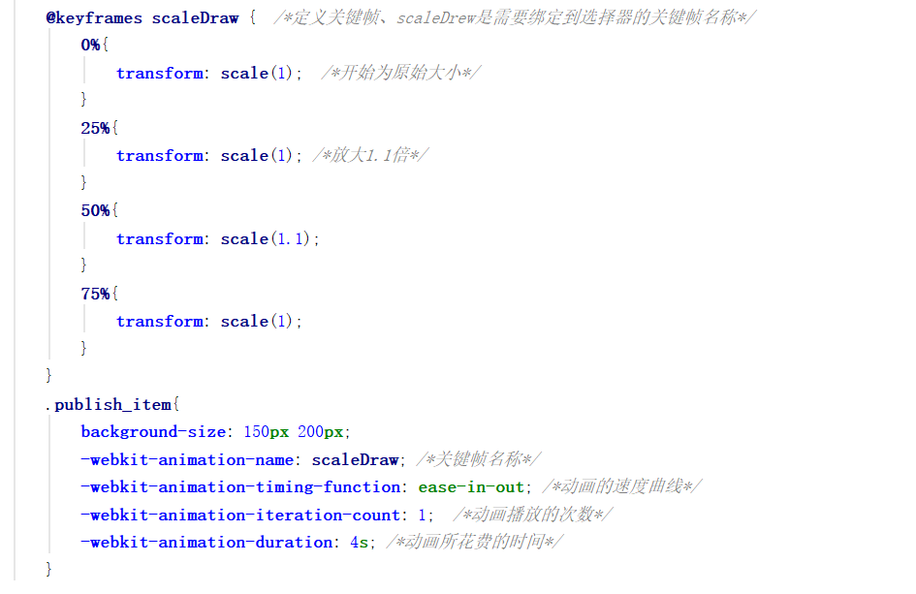

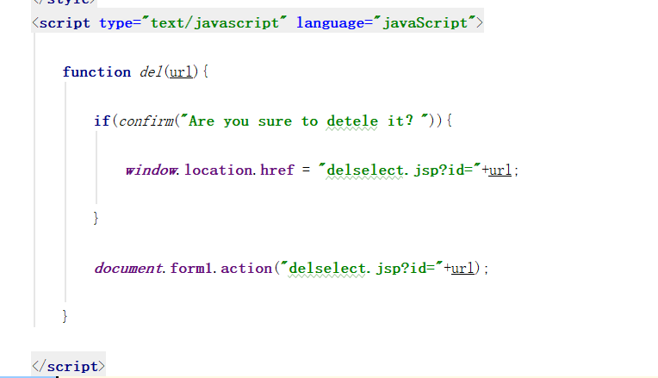

**3. Features and interfaces**

**1. Login function**

Users can enter their own username and password to log in to XMUM LIFE.

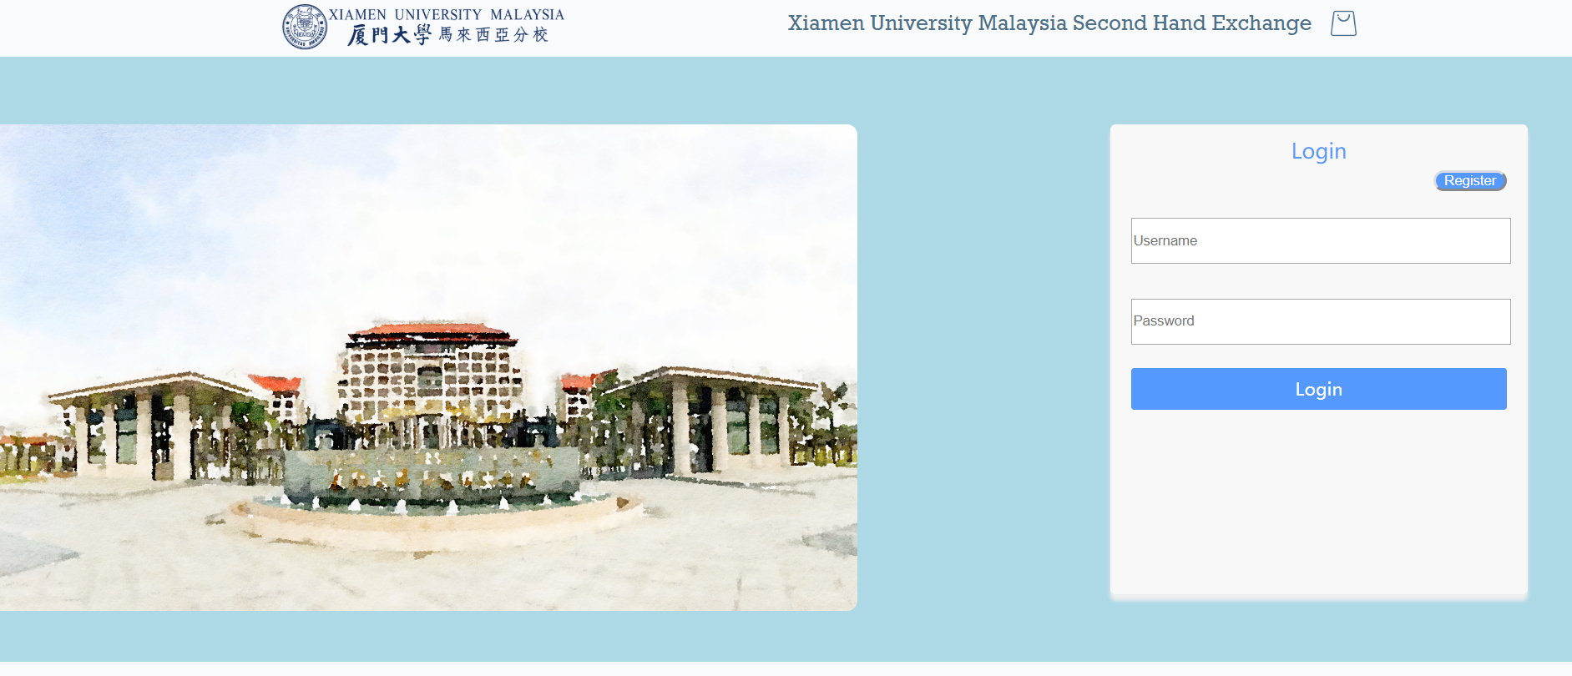

**2. Registration function**

Users can enter their own personal information, username and password, and personal avatar to register in XMUM LIFE

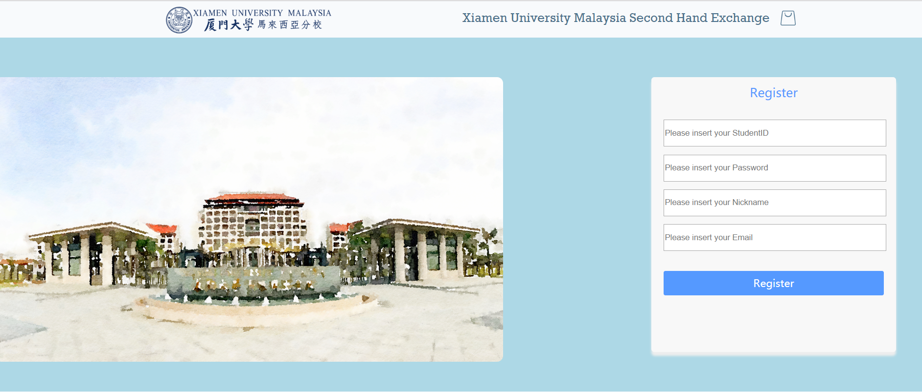

**3. Browse products**

In the XMUM LIFE, users can browser products and select something they like to purchase. On the homepage, we will recommend some products to users according to their preferences. Moreover, users also can browse products through the page about All Item. The user can also select which type of product to browse on the introduction screen of the home page.

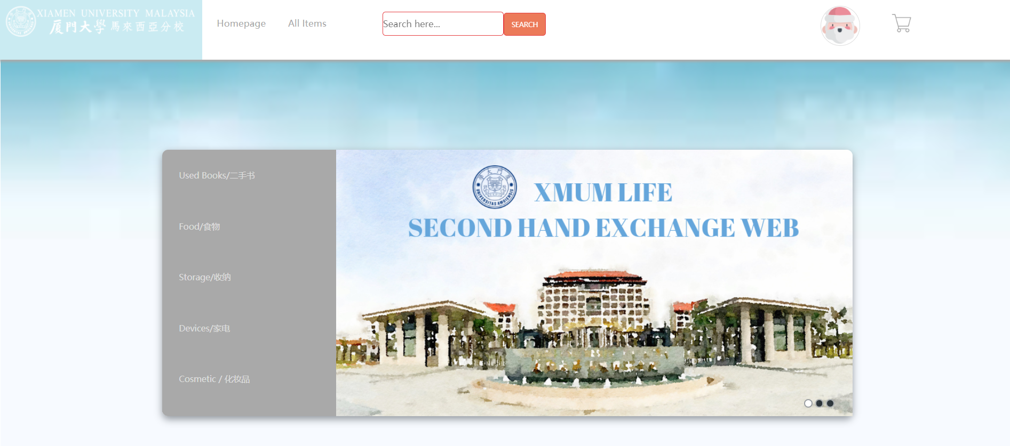

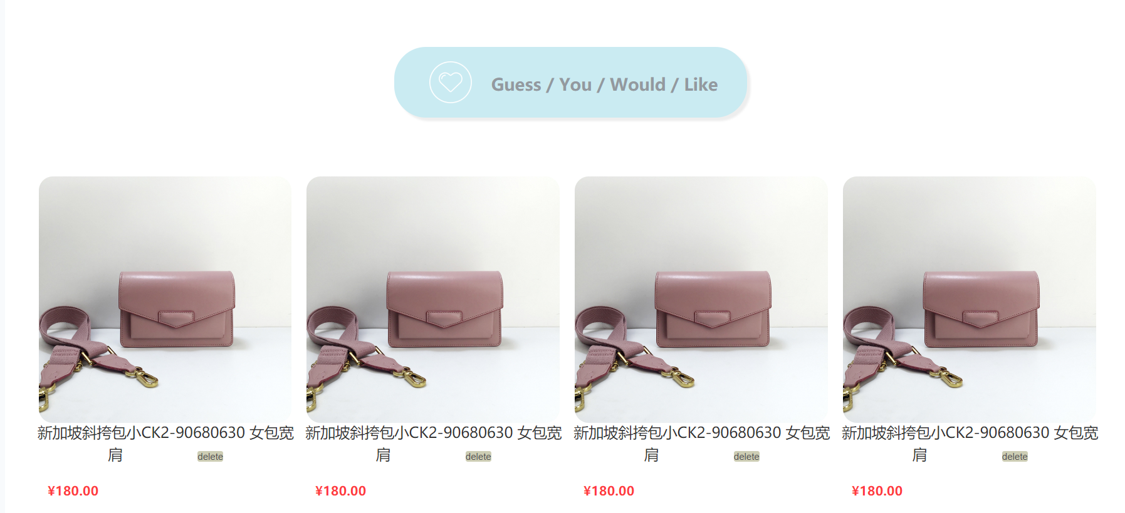

**Fetch items randomly from database**

<table class="like-item" style="width: 95%;margin: 80px auto">  
 <%  
 Class.forName("com.mysql.jdbc.Driver");  
 Statement like_item_stm = DriverManager.getConnection("jdbc:mysql://localhost:3306/peproject", "root", "admin").createStatement();  
  
 //已测试过，sql可在MySQL 可运行： 随机从item表中选8个item  
// SELECT item_id, title, price  
// FROM peproject.item  
// ORDER BY RAND() LIMIT 10  
  
 String like_item_sql ="SELECT item_id, title,picture, price \n" +  
 "FROM peproject.item \n" +  
 "ORDER BY RAND() LIMIT 8";  
 ResultSet like_item_rs = like_item_stm.executeQuery(like_item_sql);  
  
 int count=0; //  
 while(like_item_rs.next())  
 {  
 //判断是否开始新的一行  
 if(count==0||count==4){  
 %>  
 <tr class="row">  
 <%  
 }  
 %>  
 <td class="colum">  
 <a href="item_information.jsp?item_id=<%=like_item_rs.getString("item_id")%>">  
 <div>  
 <img class="item-image" src="images/<%=like_item_rs.getString("picture")%>.png">  
 </div>  
 <div class="item-text">  
 <%=like_item_rs.getString("title")%>  
  
 </div>  
 </a>  
 <div class="price">  
 $<%=like_item_rs.getString("price")%>  
 </div>  
 </td >  
 <%  
 count++;  
 //判断该行是否放满4个商品  
 if(count==4||count==8){  
 %>  
 </tr>  
 <%  
 }  
 %>  
  
 <%  
 }  
 %>  
  
 </table>

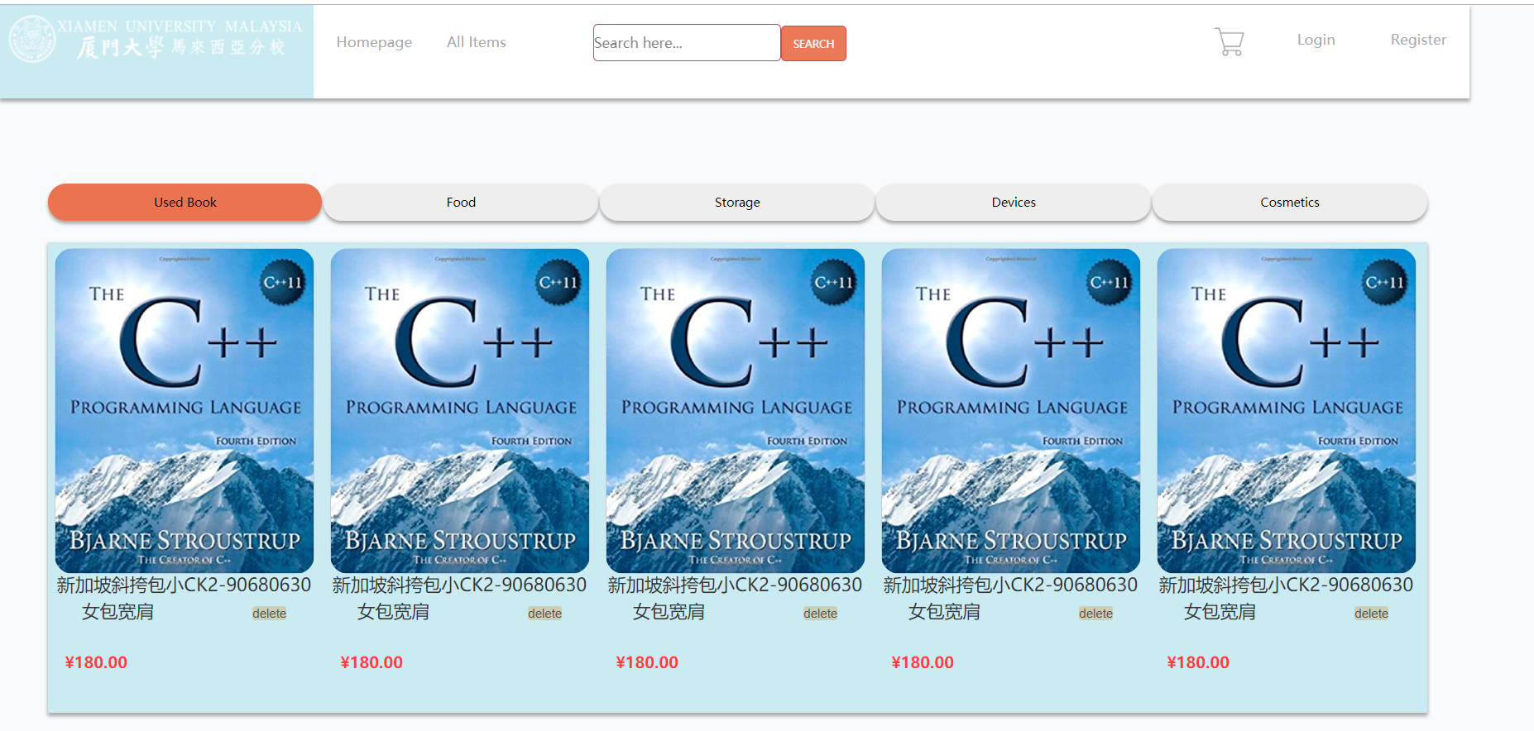

Different category have different items

<tbody class="tabPageUnSelected">  
 <%  
 Class.forName("com.mysql.jdbc.Driver");  
 Statement food_stm = DriverManager.getConnection("jdbc:mysql://localhost:3306/peproject", "root", "admin").createStatement();  
  
 //已测试过，sql可在MySQL 可运行： 放food分类下的 item  
 // category_id就让它写死吧：1为Book， 2 为Food， 3为Clothes， 4为Electronic devices， 5为Cosmetics  
// select item_id, title, price  
// from peproject.item  
// where item.catogory_id=2  
  
 String food_sql ="select item_id, title, picture,price \n" +  
 "from peproject.item\n" +  
 "where item.catogory_id=2\n";  
 ResultSet food_rs = food_stm.executeQuery(food_sql);  
  
 int count_food=0; //  
 while(food_rs.next())  
 {  
 //判断是否开始新的一行  
 if(count_food%4==0){  
 %>  
 <tr class="tabPage">  
 <tr class="row_tab" >  
 <%  
 }  
 %>  
 <td class="colum_tab">  
 <a href="item_information.jsp?item_id=<%=food_rs.getString("item_id")%>">  
 <div>  
 <img class="item-image" src="images/<%=food_rs.getString("picture")%>.png">  
 </div>  
 <div class="item-text">  
 <%=food_rs.getString("title")%>  
  
 </div>  
 </a>  
 <div class="price">  
 $<%=food_rs.getString("price")%>  
 </div>  
 </td >  
 <%  
 count_food++;  
 //判断该行是否放满4个商品  
 if(count_food%4==0 && count_food!=0){  
 %>  
  
 </tr>  
 </tr>  
 <%  
 }  
 %>  
  
 <%  
 }  
 %>  
 </tbody>  
  
  
 <!-- 这是clothes的内容部分-->  
 <tbody class="tabPageUnSelected">  
 <%  
 Class.forName("com.mysql.jdbc.Driver");  
 Statement clothes_stm = DriverManager.getConnection("jdbc:mysql://localhost:3306/peproject", "root", "admin").createStatement();  
  
 //已测试过，sql可在MySQL 可运行： 放food分类下的 item  
 // category_id就让它写死吧：1为Book， 2 为Food， 3为Clothes， 4为Electronic devices， 5为Cosmetics  
// select item_id, title, price  
// from peproject.item  
// where item.catogory_id=3  
  
 String clothes_sql ="select item_id, title, picture,price \n" +  
 "from peproject.item\n" +  
 "where item.catogory_id=3\n";  
 ResultSet clothes_rs = clothes_stm.executeQuery(clothes_sql);  
  
 int count_clothes=0; //  
 while(clothes_rs.next())  
 {  
 //判断是否开始新的一行  
 if(count_clothes%4==0){  
 %>  
 <tr class="tabPage">  
 <tr class="row_tab" >  
 <%  
 }  
 %>  
 <td class="colum_tab">  
 <a href="item_information.jsp?item_id=<%=clothes_rs.getString("item_id")%>">  
 <div>  
 <img class="item-image" src="images/<%=clothes_rs.getString("picture")%>.png">  
 </div>  
 <div class="item-text">  
 <%=clothes_rs.getString("title")%>  
  
 </div>  
 </a>  
 <div class="price">  
 $<%=clothes_rs.getString("price")%>  
 </div>  
 </td >  
 <%  
 count_clothes++;  
 //判断该行是否放满4个商品  
 if(count_clothes%4==0 && count_clothes!=0){  
 %>  
  
 </tr>  
 </tr>  
 <%  
 }  
 %>  
  
 <%  
 }  
 %>  
 </tbody>  
  
 <!--这是Eectronic devices的内容部分-->  
 <tbody class="tabPageUnSelected">  
 <%  
 Class.forName("com.mysql.jdbc.Driver");  
 Statement device_stm = DriverManager.getConnection("jdbc:mysql://localhost:3306/peproject", "root", "admin").createStatement();  
  
 //已测试过，sql可在MySQL 可运行： 放food分类下的 item  
 // category_id就让它写死吧：1为Book， 2 为Food， 3为Clothes， 4为Electronic devices， 5为Cosmetics  
// select item_id, title, price  
// from peproject.item  
// where item.catogory_id=4  
  
 String device_sql ="select item_id, title, picture,price \n" +  
 "from peproject.item\n" +  
 "where item.catogory_id=4\n";  
 ResultSet device_rs = device_stm.executeQuery(device_sql);  
  
 int count_device=0; //  
 while(device_rs.next())  
 {  
 //判断是否开始新的一行  
 if(count_device%4==0){  
 %>  
 <tr class="tabPage">  
 <tr class="row_tab" >  
 <%  
 }  
 %>  
 <td class="colum_tab">  
 <a href="item_information.jsp?item_id=<%=device_rs.getString("item_id")%>">  
 <div>  
 <img class="item-image" src="images/<%=device_rs.getString("picture")%>.png">  
 </div>  
 <div class="item-text">  
 <%=device_rs.getString("title")%>  
  
 </div>  
 </a>  
 <div class="price">  
 $<%=device_rs.getString("price")%>  
 </div>  
 </td >  
 <%  
 count_device++;  
 //判断该行是否放满4个商品  
 if(count_device%4==0 && count_device!=0){  
 %>  
  
 </tr>  
 </tr>  
 <%  
 }  
 %>  
  
 <%  
 }  
 %>  
 </tbody>  
  
  
 <!--这是cosmetics的内容部分-->  
  
 <tbody class="tabPageUnSelected">  
 <%  
 Class.forName("com.mysql.jdbc.Driver");  
 Statement cosmetics_stm = DriverManager.getConnection("jdbc:mysql://localhost:3306/peproject", "root", "admin").createStatement();  
  
 //已测试过，sql可在MySQL 可运行： 放cosmetics分类下的 item  
 // category_id就让它写死吧：1为Book， 2 为Food， 3为Clothes， 4为Electronic devices， 5为Cosmetics  
// select item_id, title, price  
// from peproject.item  
// where item.catogory_id=5  
  
 String cosmetics_sql ="select item_id, title, picture,price \n" +  
 "from peproject.item\n" +  
 "where item.catogory_id=5\n";  
 ResultSet cosmetics_rs = cosmetics_stm.executeQuery(cosmetics_sql);  
  
 int count_cosmetics=0; //  
 while(cosmetics_rs.next())  
 {  
 //判断是否开始新的一行  
 if(count_cosmetics%4==0){  
 %>  
 <tr class="tabPage">  
 <tr class="row_tab" >  
 <%  
 }  
 %>  
 <td class="colum_tab">  
 <a href="item_information.jsp?item_id=<%=cosmetics_rs.getString("item_id")%>">  
 <div>  
 <img class="item-image" src="images/<%=cosmetics_rs.getString("picture")%>.png">  
 </div>  
 <div class="item-text">  
 <%=cosmetics_rs.getString("title")%>  
  
 </div>  
 </a>  
 <div class="price">  
 $<%=cosmetics_rs.getString("price")%>  
 </div>  
 </td >  
 <%  
 count_cosmetics++;  
 //判断该行是否放满4个商品  
 if(count_cosmetics%4==0 && count_cosmetics!=0){  
 %>  
  
 </tr>  
 </tr>  
 <%  
 }  
 %>  
  
 <%  
 }  
 %>  
 </tbody>  
 </table>

**4. Publish the idle item**

In the XMUM LIFE, users can publish the idle products. The users need enter the title of the idle items, the description of the idle item, the picture of the idle items, and then theses information will be published to the XMUM LIFE.

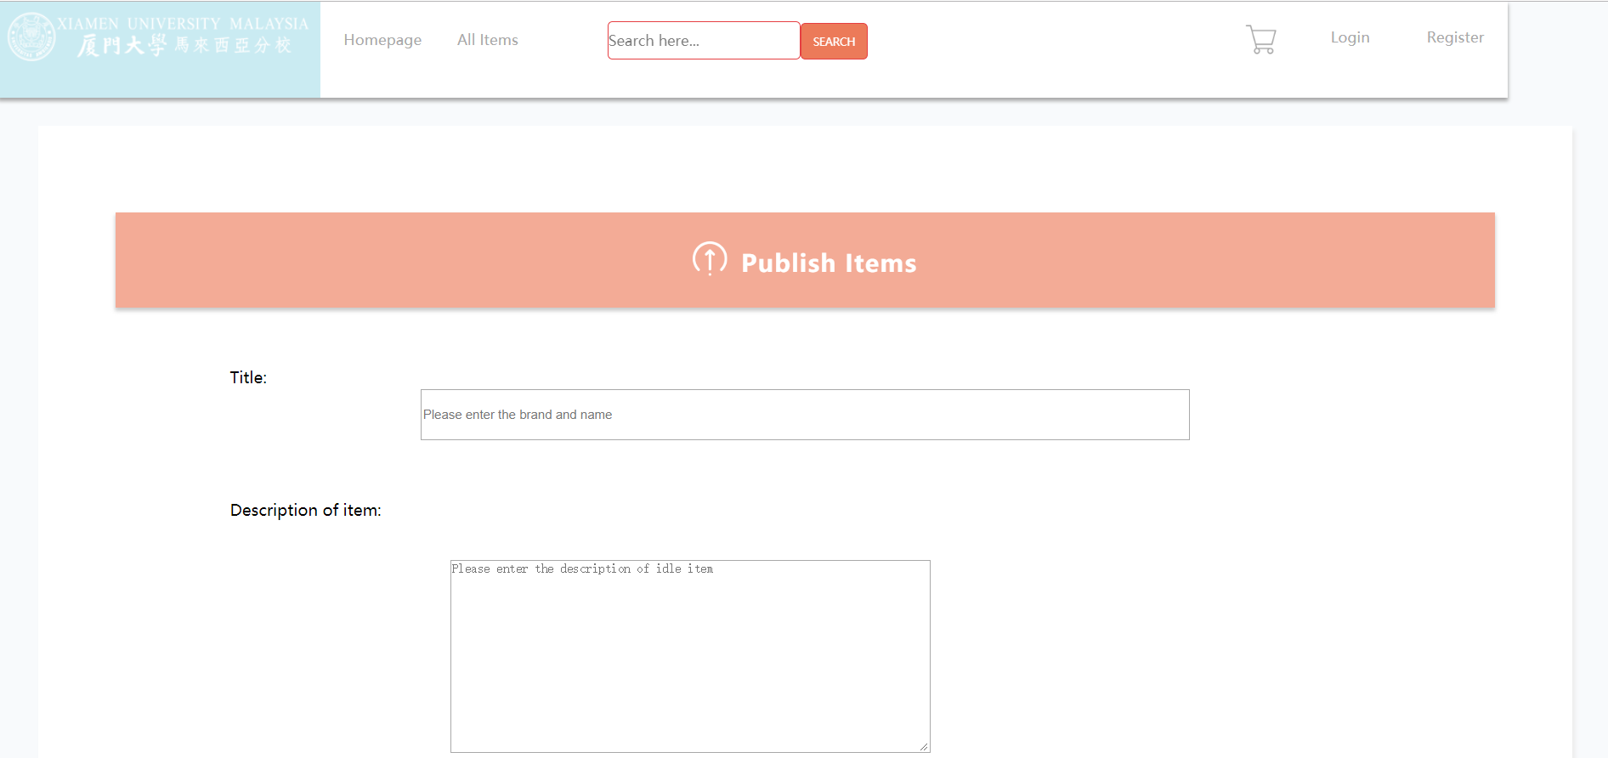

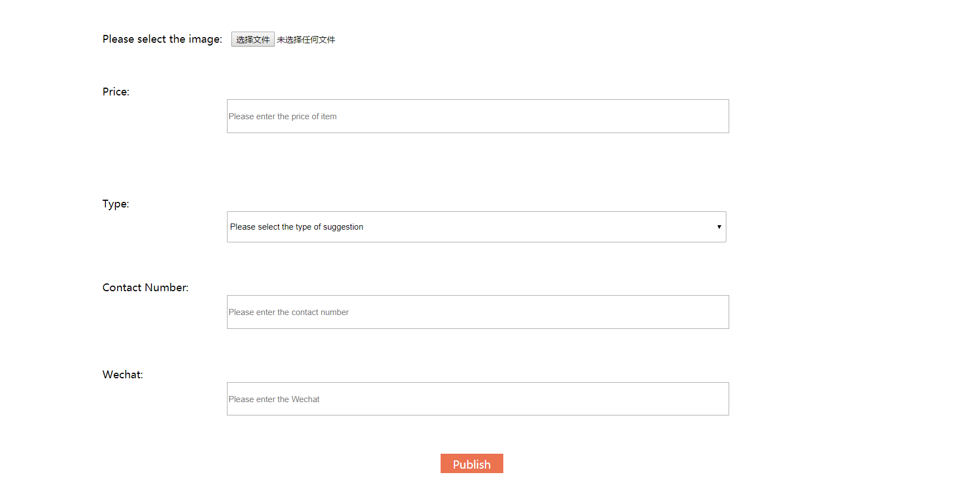

**5. My page**

In my page of users, the following functions have been implemented

* **Edit personal information**

On the personal information page, users can modify their personal information and update their username and photos.

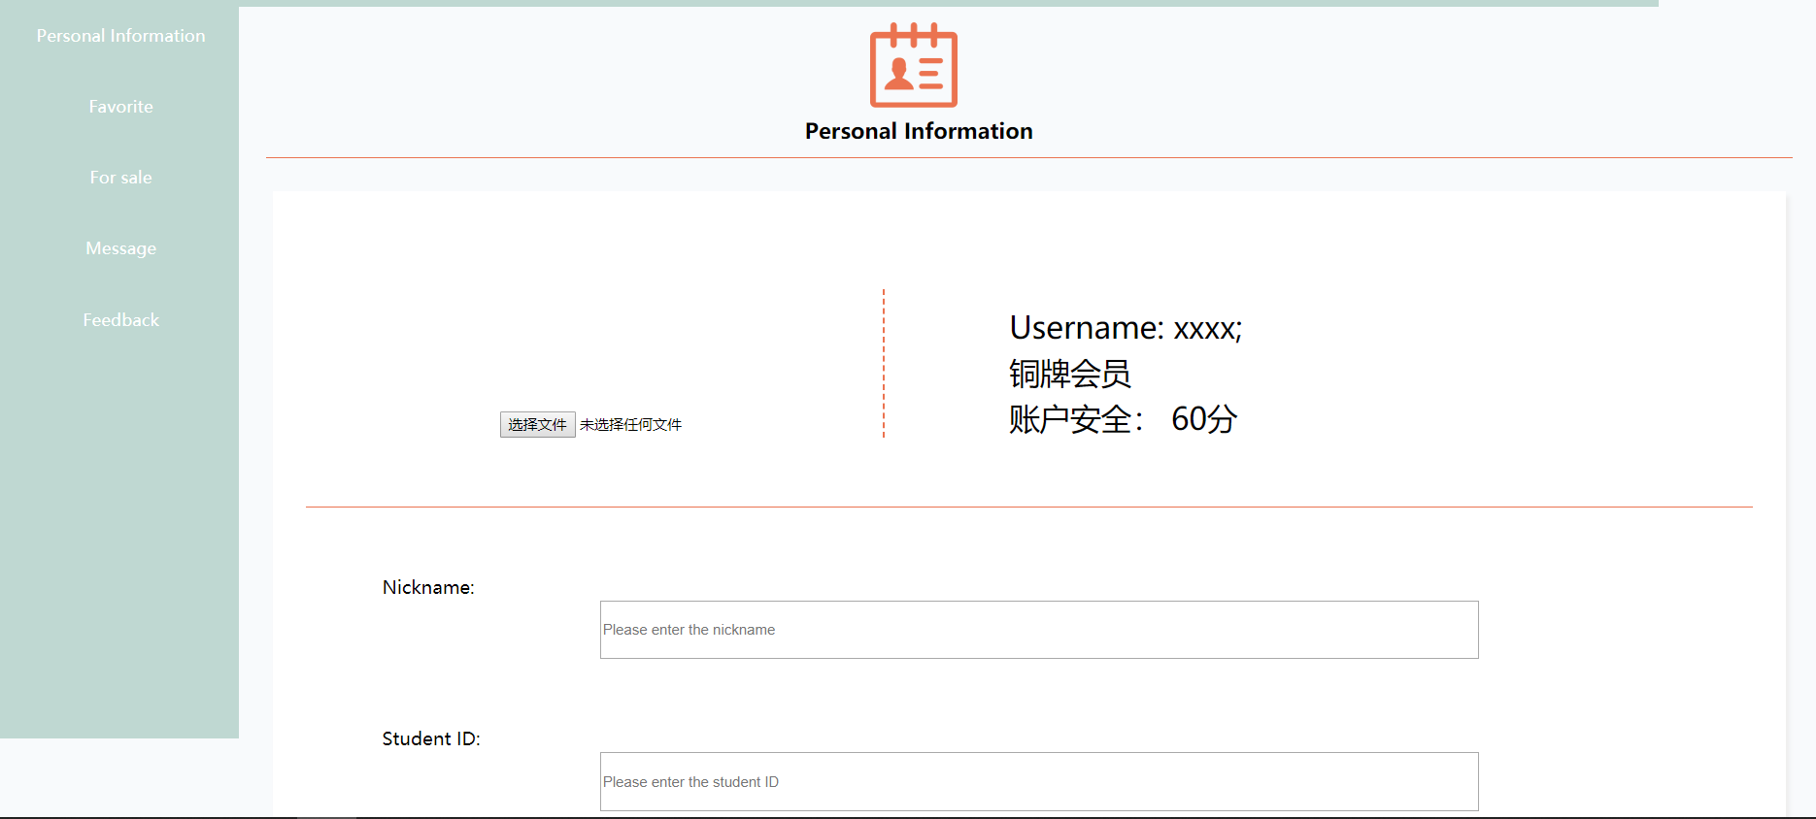

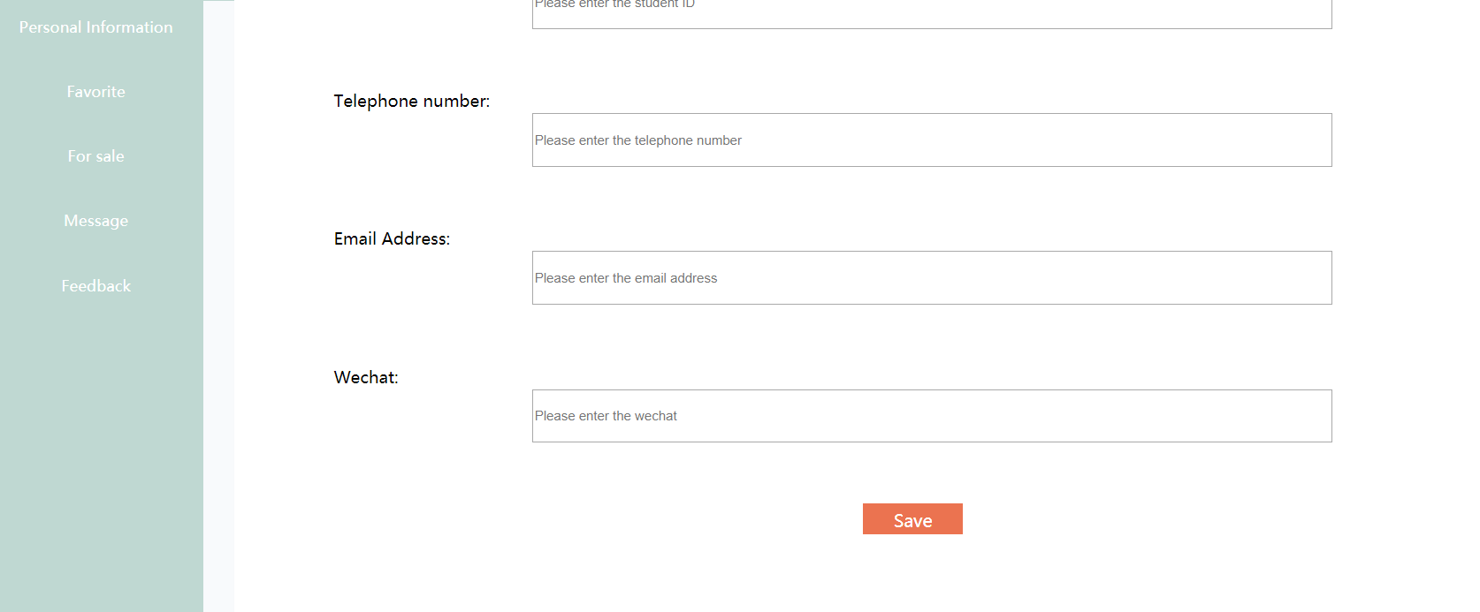

* **Favorite**

On the favorite page, the user can check the items they have collected, which is convenient for them to purchase.

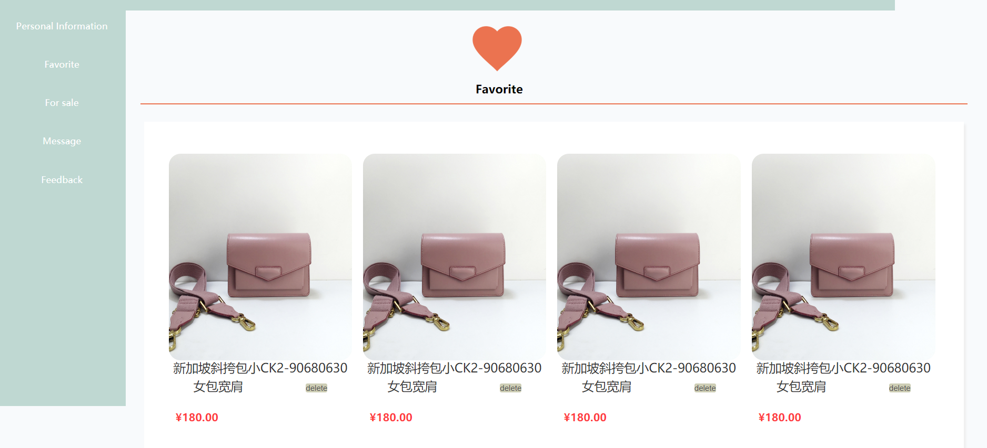

**SQL for fetch data from database**

<div class="back">  
 <table class="like-item" style="width: 95%;margin: 20px auto">  
 <%  
 Class.forName("com.mysql.jdbc.Driver");  
 Statement favorite_stm = DriverManager.getConnection("jdbc:mysql://localhost:3306/peproject", "root", "admin").createStatement();  
  
 //已测试过，sql可在MySQL 可运行： 获取该用户所有favorite item  
// select user_id, favorite_id, item_id  
// from peproject.favorite  
// where user_id=1  
  
 String favorite_sql ="select F.user_id, F.favorite_id, T.item_id, title,price,T.picture\n" +  
 "from peproject.favorite as F, peproject.item as T\n" +  
 "where F.user_id = '"+session.getAttribute("user_id")+"' and F.item_id = T.item_id";  
 ResultSet favorite_rs = favorite_stm.executeQuery(favorite_sql);  
  
 int count_favorite=0; //  
 while(favorite_rs.next())  
 {  
 //判断是否开始新的一行  
 if(count_favorite%4==0){  
 %>  
  
 <tr class="row">  
 <%  
 }  
 %>  
 <td class="colum" style="width: 250px;margin-left: 4px;">  
 <a href="item_information.jsp?item_id=<%=favorite_rs.getString("T.item_id")%>">  
 <div>  
 <img class="item-image" style="width: 250px" src="images/<%=favorite_rs.getString("picture")%>.png">  
 </div>  
 <div style="width: 250px" class="item-text">  
 <%=favorite_rs.getString("title")%>  
 <%--<input class="delete" type="button" value="delete" onclick="del()"/>--%>  
 </div>  
 </a>  
 <div class="price">  
 $<%=favorite_rs.getString("price")%>  
 </div>  
 </td >  
 <%  
 count_favorite++;  
 //判断该行是否放满4个商品  
 if(count_favorite%4==0 && count_favorite!=0){  
 %>  
 </tr>  
 <%  
 }  
 %>  
  
 <%  
 }  
 %>  
 </table>  
 </div>

* **For sale**

On this page, users can see the idle items they have published. If the user has already sold the product, they can delete this product in the for sale page.

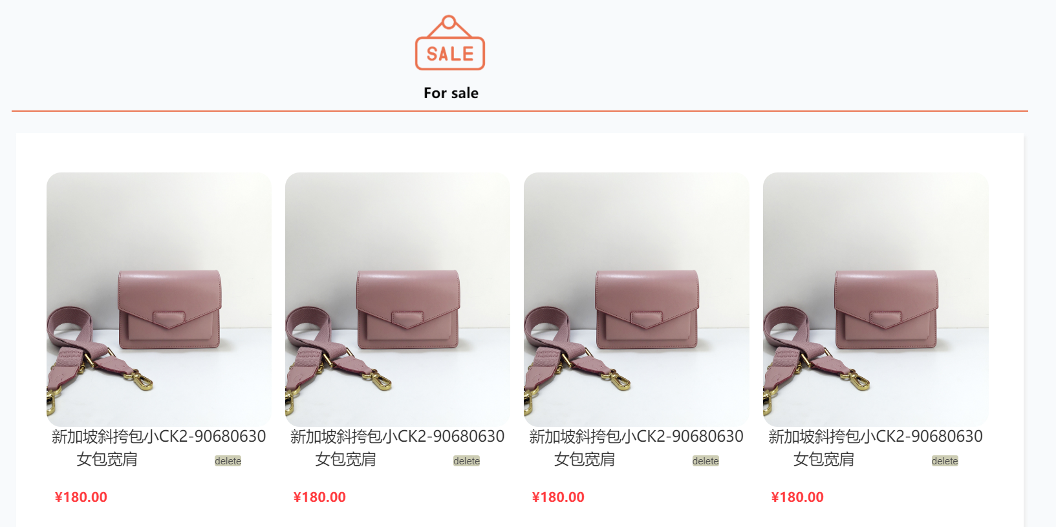

**SQL for fetch data from database**

<!-- Item-->  
 <div class="back">  
 <table class="like-item" style="width: 95%;margin: 20px auto">  
 <%  
 Class.forName("com.mysql.jdbc.Driver");  
 Statement selling_stm = DriverManager.getConnection("jdbc:mysql://localhost:3306/peproject", "root", "admin").createStatement();  
 //已测试过，sql可在MySQL 可运行： 获取该用户所有favorite item  
// select T.user_id, T.item_id, T.title, T.price  
// from peproject.user as U, peproject.item as T  
// where T.user_id = 1 and U.user_id = T.user_id  
 String selling_sql ="select T.user_id, T.item_id, T.title, T.price,picture\n" +  
 "from peproject.user as U, peproject.item as T\n" +  
 "where T.user_id = '"+session.getAttribute("user_id")+"' and U.user_id = T.user_id\n";  
 ResultSet selling_rs = selling_stm.executeQuery(selling_sql);  
  
 int count_selling=0;  
 while(selling_rs.next())  
 {  
 //判断是否开始新的一行  
 session.setAttribute("item_id", selling_rs.getString("item_id"));  
 if(count_selling%4==0){  
 %>  
 <tr class="row">  
 <%  
 }  
 %>  
 <td class="colum" style="width: 250px;margin-left: 4px;">  
 <a href="item_information.jsp?item_id=<%=selling_rs.getString("T.item_id")%>">  
 <div>  
 <img class="item-image" src="images/<%=selling_rs.getString("picture")%>.png" style="width: 250px">  
 </div>  
 <div class="item-text" style="width: 250px;h">  
 <%=selling_rs.getString("title")%>  
 <%--<form name="form2" method="">--%>  
 <%--<input style="display: inline-block;margin-top: -20px" class="delete" type="button" value="delete" onclick="del()"/>--%>  
 <%--</form>--%>  
 </div>  
 </a>  
 <div class="price" style="display: inline-block">  
 $<%=selling_rs.getString("price")%>  
 </div>  
 <form name="form2" action="/DeleteItem" method="post" style="display: inline-block;position: relative; top: 200px;left: 70px">  
 <input class="delete" type="submit" value="delete" <%--onclick="del()"--%>/>  
 </form>  
 </td >  
 <%  
 count_selling++;  
 //判断该行是否放满4个商品  
 if(count_selling%4==0 && count_selling!=0){  
 %>  
 </tr>  
 <%  
 }  
 %>  
 <%  
 }  
 %>  
 </table>  
 </div>

**6. Leave a message**

Users can leave a message in the product details page, and then this message will be displayed after they submitted the messages. When the buyer sends the message in the product details page, the seller of product can receive the message in the message page.

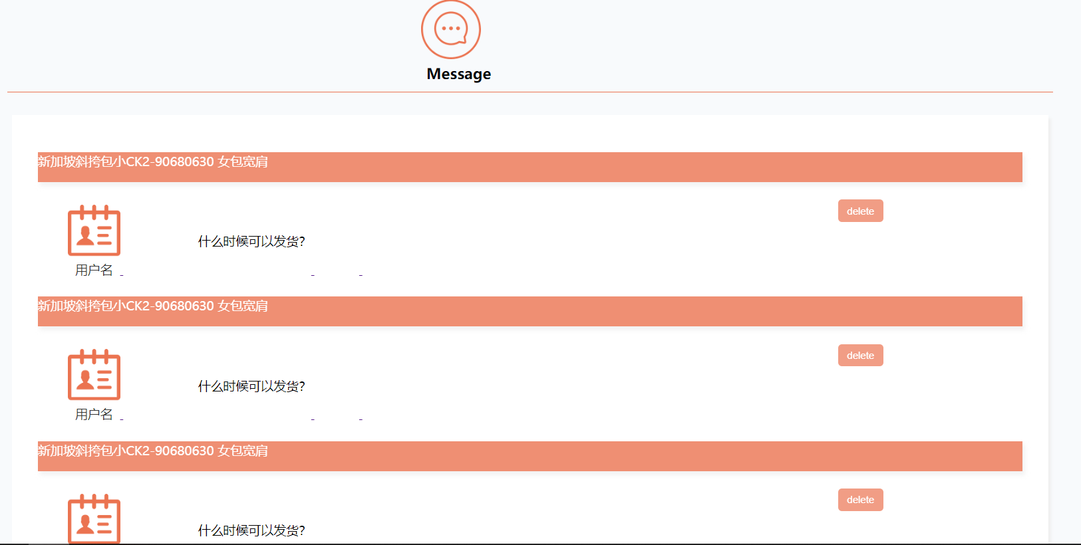

**7. Feedback**

We provide feedback function, users can fill in feedback information on the feedback page, and then we can receive feedbacks to improve the XMUM LIFE.

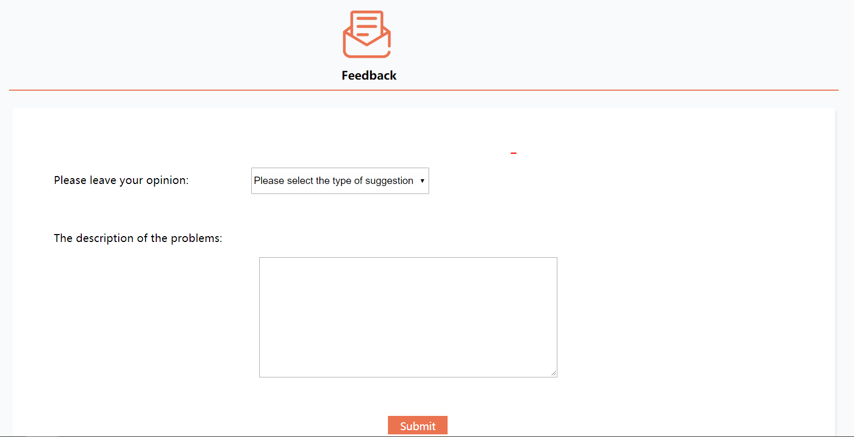

**8. Search function**

The user can search the keyword of the product, and then the search page will display the product containing this keyword.

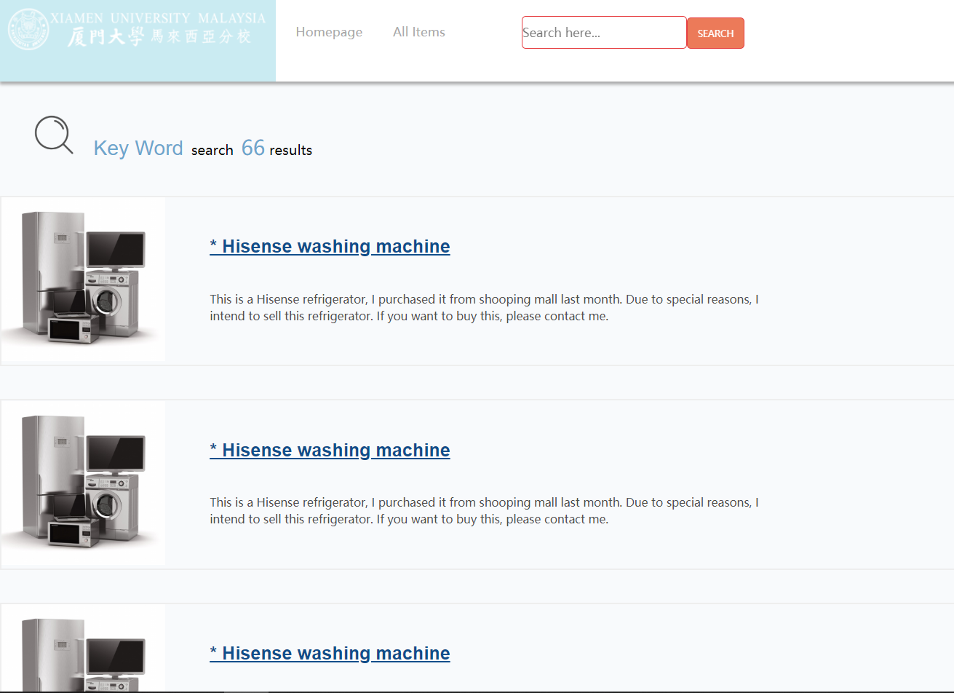

**9. Browser Item Information**

The user can select a product, and then browse this product in item information page, which displays the picture, name, price, and description of the item. The users can leave a message on the item details page to the seller.

**9. Booking cart**

If the users are interested in the idle item, they can add it to the book cart, then they can check the price and book the item, after they check out the item, it will display the user information, then users can contact with the seller.

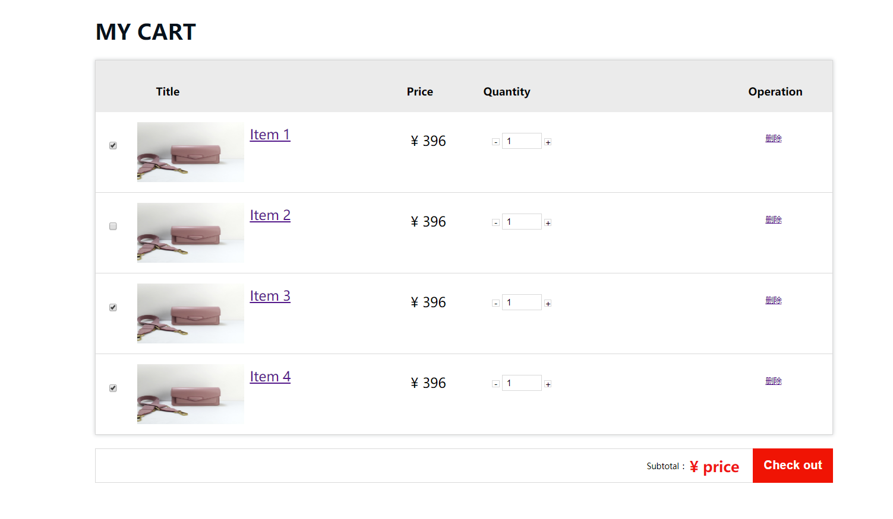

**Pass the parameter to my cart**

<%

String iid=request.getParameter("item_id");

%>

<div class="bd" >

<%  
 //sql语句select item 信息  
 Class.forName("com.mysql.jdbc.Driver");  
 Statement booking_stm = DriverManager.getConnection("jdbc:mysql://localhost:3306/peproject", "root", "admin").createStatement();

//已测试过，sql可在MySQL 可运行：  
// select item_id, title, price, description, U.user_id, nickname  
// from peproject.item, peproject.user as U  
// where item.item_id=1 and item.user_id=U.user_id  
  
 String booking_sql ="select T.item_id,T.price,picture,T.title\n" +  
 "from peproject.item as T\n" +  
 "where T.item_id='"+iid+"'";  
  
 ResultSet booking_rs = booking_stm.executeQuery(booking_sql);  
 while(booking_rs.next())  
 {  
%>  
 <!-- 商品列表 -->  
 <ul class="order-list">  
 <li><input type="checkbox" class="check" checked></li>  
 <li class="img-box">  
  
 <img src="images/<%=booking_rs.getString("picture")%>.png"/> >  
  
 </li>  
 <li class="product" style="margin-top: 30px">  
 <a href="">  
 <span><%=booking_rs.getString("title")%></span>  
 </a>  
 </li>  
  
 <li class="unit-price">  
 <span class="price-sign">$</span>  
 <span class="price-num">

<%=booking_rs.getString("price")%></span>  
 </li>  
 </ul>  
  
</div>

**5. Responsibility of team members**

**ZENG LIJIE:**

Responsible for back-end development, database development

**XIE YIDAN:**

Responsible for front end development and collecting item information

**LING ZIQI:**

Responsible for database design and connection between the front end and database

**6.Servlet**

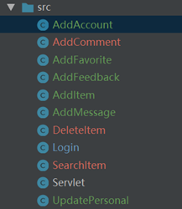

**6.1 AddAccount.java as a Register**

import javax.servlet.ServletException;

import javax.servlet.annotation.WebServlet;

import javax.servlet.http.HttpServlet;

import javax.servlet.http.HttpServletRequest;

import javax.servlet.http.HttpServletResponse;

import javax.servlet.http.HttpSession;

import java.io.IOException;

import java.sql.DriverManager;

import java.sql.Statement;

import java.text.SimpleDateFormat;

@WebServlet(name = "AddAccount")

public class AddAccount extends HttpServlet {

protected void doPost(HttpServletRequest request, HttpServletResponse response) throws ServletException, IOException {

HttpSession session=request.getSession();

String student_id=request.getParameter("student_id");

String password=request.getParameter("password");

String nickname=request.getParameter("nickname");

String email=request.getParameter("email");

String wechat=request.getParameter("wechat");

String whatsapp=request.getParameter("whatsapp");

String qq=request.getParameter("qq");

if(student_id.equals("")||password.equals("")){ response.setHeader("refresh", "3;url=register.jsp"); }

try {

Class.forName("com.mysql.jdbc.Driver");

Statement stm = DriverManager.getConnection("jdbc:mysql://localhost:3306/peproject", "root", "admin").createStatement();

java.util.Date d=new java.util.Date();

SimpleDateFormat sdf=new SimpleDateFormat("yyyy-MM-dd hh:mm:ss");

String da= sdf.format(d);//register_time

String sql =

"Insert into peproject.user(student_id,password,nickname,email,wechat,whatsapp,qq,register_date) \n" +

"values('"+ student_id+"','"+password+"','"+nickname+"','"+email+"','"+wechat+"','"+whatsapp+"','"+qq+"','"+da+"');";

stm.execute(sql);

response.sendRedirect("login.jsp");

}

catch (Exception e)

{

e.printStackTrace();

}

}

protected void doGet(HttpServletRequest request, HttpServletResponse response) throws ServletException, IOException {

}

}

**6.2 Addcomment.java:**

This part, we use the time,sender_id,,item_id to track each comment!

import javax.servlet.ServletException;

import javax.servlet.annotation.WebServlet;

import javax.servlet.http.HttpServlet;

import javax.servlet.http.HttpServletRequest;

import javax.servlet.http.HttpServletResponse;

import java.io.IOException;

import java.lang.*;

import javax.servlet.http.HttpSession;

import java.text.SimpleDateFormat;

import java.sql.Statement;

import java.sql.DriverManager;

@WebServlet(name = "AddComment")

public class AddComment extends HttpServlet {

protected void doPost(HttpServletRequest request, HttpServletResponse response) throws ServletException, IOException {

String iid = request.getParameter("item_id");

String content = request.getParameter("content");

HttpSession session = request.getSession();

response.getWriter().write("item_id");

try {

Class.forName("com.mysql.jdbc.Driver");

java.util.Date d=new java.util.Date();

SimpleDateFormat sdf=new SimpleDateFormat("yyyy-MM-dd hh:mm:ss");

String da= sdf.format(d);//collect_time

Statement stm = DriverManager.getConnection("jdbc:mysql://localhost:3306/peproject", "root", "admin").createStatement();

String sql = "insert into peproject.comment(item_id,content,user_id,sender_id,time) \n" +

"values('"+ iid+"','"+ content +"','" + session.getAttribute("user_id") +"','"+iid+"','"+da+"')";

response.getWriter().println(sql);

stm.execute(sql);

response.sendRedirect("item_information.jsp?item_id="+iid);

} catch (Exception e) {

e.printStackTrace();

}

}

protected void doGet(HttpServletRequest request, HttpServletResponse response) throws ServletException, IOException {

return;

}

}

**6.3 AddFavorite: use this to complete a Favorites functions**

import javax.servlet.ServletException;

import javax.servlet.annotation.WebServlet;

import javax.servlet.http.HttpServlet;

import javax.servlet.http.HttpServletRequest;

import javax.servlet.http.HttpServletResponse;

import javax.servlet.http.HttpSession;

import java.io.IOException;

import java.sql.DriverManager;

import java.sql.Statement;

import java.text.SimpleDateFormat;

@WebServlet(name = "AddFavorite")

public class AddFavorite extends HttpServlet {

protected void doPost(HttpServletRequest request, HttpServletResponse response) throws ServletException, IOException {

}

protected void doGet(HttpServletRequest request, HttpServletResponse response) throws ServletException, IOException {

HttpSession session=request.getSession();//use session to know item_id and user_id

String item_id=session.getAttribute("item_id").toString();

String user_id=session.getAttribute("user_id").toString();

try {

Class.forName("com.mysql.jdbc.Driver");

Statement stm = DriverManager.getConnection("jdbc:mysql://localhost:3306/peproject", "root", "admin").createStatement();

java.util.Date d=new java.util.Date();

SimpleDateFormat sdf=new SimpleDateFormat("yyyy-MM-dd hh:mm:ss");

String da= sdf.format(d);//collect_time

String sql =

"Insert into peproject.favorite(item_id,user_id,collect_time) \n" +

"values('" +item_id+"',' "+user_id+"','"+da+"');";

stm.execute(sql);

response.sendRedirect("Favorites.jsp");

}

catch (Exception e)

{

e.printStackTrace();

}

}

}

**6.4 AddFeedback: we receive the different type of feedback and record their data to our customer service center. And in the future, we will send an email to user.**

import javax.servlet.ServletException;

import javax.servlet.annotation.WebServlet;

import javax.servlet.http.HttpServlet;

import javax.servlet.http.HttpServletRequest;

import javax.servlet.http.HttpServletResponse;

import javax.servlet.http.HttpSession;

import java.io.IOException;

import java.sql.DriverManager;

import java.sql.Statement;

import java.text.SimpleDateFormat;

@WebServlet(name = "AddFeedback")

public class AddFeedback extends HttpServlet {

protected void doPost(HttpServletRequest request, HttpServletResponse response) throws ServletException, IOException {

HttpSession session=request.getSession();//use session to know item_id and user_id

String type=request.getParameter("selectAge");

String description =request.getParameter("description");

String student_id=session.getAttribute("student_id").toString();

response.getWriter().write(session.getAttribute("student_id").toString());

try {

Class.forName("com.mysql.jdbc.Driver");

Statement stm = DriverManager.getConnection("jdbc:mysql://localhost:3306/peproject", "root", "admin").createStatement();

java.util.Date d=new java.util.Date();

SimpleDateFormat sdf=new SimpleDateFormat("yyyy-MM-dd hh:mm:ss");

String da= sdf.format(d);//collect_time

String sql =

"Insert into feedback(user_id,type,description,release_time)\n" +

"values('"+session.getAttribute("user_id")+"','"+type+"','"+description+"', '"+da+"')";

stm.execute(sql);

response.sendRedirect("Feedback_successful.jsp");

}

catch (Exception e)

{

e.printStackTrace();

}

}

protected void doGet(HttpServletRequest request, HttpServletResponse response) throws ServletException, IOException {

}

}

**6.5 AddItem: we use this to publish the item to the server, we record item’s all information and the picture of it based on its upload time.**

import javax.servlet.ServletException;

import javax.servlet.annotation.MultipartConfig;

import javax.servlet.annotation.WebServlet;

import javax.servlet.http.*;

import java.io.FileOutputStream;

import java.io.IOException;

import java.io.InputStream;

import java.sql.DriverManager;

import java.sql.Statement;

import java.text.SimpleDateFormat;

import java.util.Date;

@MultipartConfig

@WebServlet(name = "AddItem")

public class AddItem extends HttpServlet {

protected void doPost(HttpServletRequest request, HttpServletResponse response) throws ServletException, IOException {

doGet(request,response);

}

protected void doGet(HttpServletRequest request, HttpServletResponse response) throws ServletException, IOException {

HttpSession session=request.getSession();

String type=request.getParameter("selectAge");

String title=request.getParameter("title");

String price=request.getParameter("price");

String description=request.getParameter("description");

String contact_information=request.getParameter("contact_information");

Date d = new Date();

SimpleDateFormat sdf = new SimpleDateFormat("yyyyMMddHHmmss");

String dada = sdf.format(d);

Part image = request.getPart("image");

InputStream is = image.getInputStream();

byte[] content = is.readAllBytes();

if (content.length < 2) {

response.getWriter().write("12");

dada = "777";

} else {

FileOutputStream fout = new FileOutputStream(

request.getServletContext().getRealPath("images/") + dada + ".png");

fout.write(content);

fout.close();

response.getWriter().write("21");

}

try {

Class.forName("com.mysql.jdbc.Driver");

Statement stm = DriverManager.getConnection("jdbc:mysql://localhost:3306/peproject", "root", "admin").createStatement();

java.util.Date d1=new java.util.Date();

SimpleDateFormat sdf1=new SimpleDateFormat("yyyy-MM-dd hh:mm:ss");

String da= sdf1.format(d1);//collect_time

response.getWriter().write(session.getAttribute("student_id").toString());

response.getWriter().write("type");

String sql =

"Insert into peproject.item(user_id,catogory_id,picture,title,price,description,contact_information,release_time) \n" +

"values('"+session.getAttribute("user_id")+"','"+type+"','"+dada+"','"+title+"','"+price+"','"+description+"','"+contact_information+"','"+da+"');";

stm.execute(sql);

response.sendRedirect("Success_sumbmit.jsp");

}

catch (Exception e)

{

e.printStackTrace();

}

}

}

**6.6 DeleteItem.java**

import javax.servlet.ServletException;

import javax.servlet.annotation.WebServlet;

import javax.servlet.http.HttpServlet;

import javax.servlet.http.HttpServletRequest;

import javax.servlet.http.HttpServletResponse;

import javax.servlet.http.HttpSession;

import java.io.IOException;

import java.sql.DriverManager;

import java.sql.Statement;

import java.text.SimpleDateFormat;

@WebServlet(name = "DeleteItem")

public class DeleteItem extends HttpServlet {

protected void doPost(HttpServletRequest request, HttpServletResponse response) throws ServletException, IOException {

HttpSession session=request.getSession();

try {

Class.forName("com.mysql.jdbc.Driver");

Statement stm = DriverManager.getConnection("jdbc:mysql://localhost:3306/peproject", "root", "admin").createStatement();

String sql = "delete \n" +

"from item\n" +

"where item_id='"+session.getAttribute("item_id")+"';";

stm.execute(sql);

response.sendRedirect("For_sale.jsp");

}

catch (Exception e)

{

e.printStackTrace();

}

}

protected void doGet(HttpServletRequest request, HttpServletResponse response) throws ServletException, IOException {

}

}

**6.7 Login.java we consider the security,so we set the condition to prevent the hacker**

import javax.servlet.ServletException;

import javax.servlet.annotation.WebServlet;

import javax.servlet.http.HttpServlet;

import javax.servlet.http.HttpServletRequest;

import javax.servlet.http.HttpServletResponse;

import javax.servlet.http.HttpSession;

import java.io.IOException;

import java.io.PrintWriter;

import java.sql.DriverManager;

import java.sql.ResultSet;

import java.sql.Statement;

import static java.lang.Class.*forName*;

import static java.lang.System.*out*;

@WebServlet(name = "Login")

public class Login extends HttpServlet {

protected void doPost(HttpServletRequest request, HttpServletResponse response) throws ServletException, IOException {

HttpSession session=request.getSession();

String student_id=request.getParameter("student_id");

student_id=student_id.replace("\'","");

String password=request.getParameter("password");

password=password.replace("\'","");

try {

Statement stm = DriverManager.*getConnection*("jdbc:mysql://localhost:3306/peproject", "root", "admin").createStatement();

String sql = "select *\n" +

"from peproject.user\n" +

"where student_id='"+student_id+"' and password='"+password+"'";

ResultSet rs = stm.executeQuery(sql);

if (rs.next()) {

session.setAttribute("student_id", student_id);

session.setAttribute("user_id", rs.getString("user_id"));

response.sendRedirect("homepage.jsp");

}

else

{*out*.print("failure");

response.sendRedirect("404.jsp");

}

}

catch (Exception e)

{

e.printStackTrace();

}

}

protected void doGet(HttpServletRequest request, HttpServletResponse response) throws ServletException, IOException {

}

}

**6.8 Search_item we use this to achieve the function of search**

import javax.servlet.ServletException;

import javax.servlet.annotation.WebServlet;

import javax.servlet.http.HttpServlet;

import javax.servlet.http.HttpServletRequest;

import javax.servlet.http.HttpServletResponse;

import javax.servlet.http.HttpSession;

import java.io.IOException;

import java.sql.DriverManager;

import java.sql.ResultSet;

import java.sql.Statement;

import static java.lang.System.*out*;

@WebServlet(name = "SearchItem")

public class SearchItem extends HttpServlet {

protected void doPost(HttpServletRequest request, HttpServletResponse response) throws ServletException, IOException {

HttpSession session=request.getSession();

String search_content=request.getParameter("search_content");

session.setAttribute("search_content", search_content);

response.sendRedirect("search.jsp");

}

protected void doGet(HttpServletRequest request, HttpServletResponse response) throws ServletException, IOException {

}

}

**6.9 Update Personal**

**we use this to update personal info, and change the password.**

import javax.servlet.ServletException;

import javax.servlet.annotation.WebServlet;

import javax.servlet.http.HttpServlet;

import javax.servlet.http.HttpServletRequest;

import javax.servlet.http.HttpServletResponse;

import javax.servlet.http.HttpSession;

import java.io.IOException;

import java.sql.DriverManager;

import java.sql.Statement;

import java.text.SimpleDateFormat;

@WebServlet(name = "UpdatePersonal")

public class UpdatePersonal extends HttpServlet {

protected void doPost(HttpServletRequest request, HttpServletResponse response) throws ServletException, IOException {

}

protected void doGet(HttpServletRequest request, HttpServletResponse response) throws ServletException, IOException {

HttpSession session=request.getSession();//use session to know item_id and user_id

String student_id=session.getAttribute("student_id").toString();

String user_id=session.getAttribute("user_id").toString();

String nickname=request.getParameter("nickname");

String password=request.getParameter("password");

String email=request.getParameter("email");

String wechat=request.getParameter("nickname");

String whatsapp=request.getParameter("whatsapp");

String qq=request.getParameter("qq");

try {

Class.forName("com.mysql.jdbc.Driver");

Statement stm = DriverManager.getConnection("jdbc:mysql://localhost:3306/peproject", "root", "admin").createStatement();

String sql =

"update user \n" +

"set password='"+password+"',nickname='"+nickname+"',email='"+email+"',wechat='"+wechat+"',whatsapp='"+whatsapp+"',qq='"+qq+"' " +

"where user_id='"+user_id+"';";

stm.execute(sql);

response.sendRedirect("Personal_Information.jsp");

}

catch (Exception e)

{

e.printStackTrace();

}

}

}

**7. JSP**

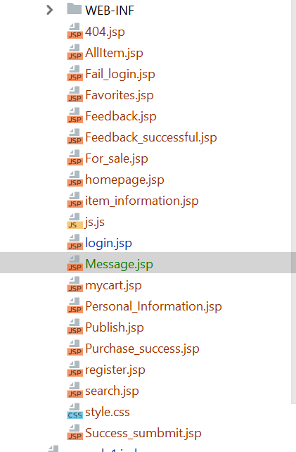

1. All Item

*<!-- *************************************-->*

<%@ **page import**="**java.sql.Statement**" %>

<%@ **page import**="**java.sql.DriverManager**" %>

<%@ **page import**="**java.sql.ResultSet**" %>

*<!-- ****************************************-->*

<!DOCTYPE **html**>

**<%**

**if** (session.getAttribute(**"student_id"**)==**null**)

response.sendRedirect(**"login.jsp"**);

**%>**

<**html lang="en"**>

<**head**>

<**meta charset="UTF-8"**>

<**title**>All Items</**title**>

<**meta name="viewport" content="width=device-width, initial-scale=1, maximum-scale=1"**>

<**link rel="stylesheet" href="style.css"**>

<**script type="text/javascript" src="js.js"**></**script**>

<**style type="text/css"**>

*<!--*

**label** {**display**:**block**;}

*-->*

</**style**>

</**head**>

<**body**>

*<!-- Header -->*

<**div class="header"** >

<**div style="background-color**:**#CAEBF2**; **width**: 337**px**; **height**:100**px**; **float**: **left"**>

<**img src="images/a.png" height="70" width="337"**/></**div**>

<**div style="float**:**right**; **margin-top**: -3**px**;**"**>

<**div style="display**: **inline-block**;**position**: **relative**;**left**: -250**px"**>

*<!--Personal information-->*

<**div id="nav"**>

<**div class="user-card"**>

<**div class="user-card-item"**>

<**div class="user-img"**>

<**a href="#"** ><**img src="./images/person_info.png"**></**a**>

</**div**>

<**div class="user-info"**>

<**img src="./images/person_info.png" class="info-img"**>

<**div class="user_name"**> <**p**> **<%**

out.print(session.getAttribute(**"student_id"**));

**%>**</**p**> *<!--数据库需要读取-->* </**div**>

<**hr style="opacity**: 0.2;**" class="grey"**>

<**div class="select_Button"**>

<**div class="first" style="margin-top**: 20**px**;**margin-left**: 25**px"**>

*<!-- 1-->*

<**a href="For_sale.jsp" target="_self" style="display**: **inline-block**;**margin-right**: 5**px"**>

<**div class="for_sale"** >

<**img style="display**: **inline-block**;**width**: 35**px**;**height**: 35**px**;**margin-left**: 5**px" src="./images/On-Sale.png"**>

<**p style="display**: **inline-block**;**position**: **relative**;**top**:-10**px**;**font-weight**: **bold"**>For Sale</**p**>

</**div**>

</**a**>

*<!-- 2 -->*

<**a href="Favorites.jsp" target="_self" style="display**: **inline-block"**>

<**div class="for_sale"**>

<**img style="display**: **inline-block**;**width**: 35**px**;**height**: 35**px**;**margin-left**: 5**px" src="./images/favorite.png"**>

<**p style="display**: **inline-block**;**position**: **relative**;**top**:-10**px**;**font-weight**: **bold"**>Favorite</**p**>

</**div**>

</**a**>

</**div**>

<**div class="second" style="margin-top**:5**px**;**margin-left**: 25**px"**>

*<!-- 1-->*

<**a href="Feedback.jsp" target="_self" style="display**: **inline-block**;**margin-right**: 5**px"**>

<**div class="for_sale"**>

<**img style="display**: **inline-block**;**width**: 35**px**;**height**: 35**px**;**margin-left**: 5**px" src="./images/feedback.png"**>

<**p style="display**: **inline-block**;**position**: **relative**;**top**:-10**px**;**font-weight**: **bold"**>Feedback</**p**>

</**div**>

</**a**>

*<!-- 2 -->*

<**a href="Personal_Information.jsp" target="_self" style="display**: **inline-block"**>

<**div class="for_sale"**>

<**img style="display**: **inline-block**;**width**: 35**px**;**height**: 35**px**;**margin-left**: 5**px" src="./images/person.png"**>

<**p style="display**: **inline-block**;**position**: **relative**;**top**:-10**px**;**font-weight**: **bold"**>Personal</**p**>

</**div**>

</**a**>

</**div**>

<**hr style="margin-top**: 20**px**;**opacity**:0.2;**" class="grey"**>

<**div class="user_text"**>

<**a href="login.jsp" target="_self"**>Log out</**a**>

</**div**>

</**div**>

</**div**>

</**div**>

</**div**>

</**div**>

</**div**>

*<!--Cart-->*

<**div style="display**: **inline-block**;**position**: **relative**;**left**: -50**px" class="topics"**>

<**a class="link" href="mycart.jsp" target="_self"**>

<**img style="width**: 35**px**;**height**: 35**px**;**margin-top**: 25**px**;**margin-left**: 35**px" src="./images/cart.png"**>

</**a**>

</**div**>

</**div**>

<**ul**>

<**li class="topics" style="margin-left**: 10**px"**>

<**a class="link" href="homepage.jsp" target="_self"**>Homepage</**a**>

</**li**>

<**li class="topics"**>

<**a class="link" href="AllItem.jsp" target="_self"**>All Items</**a**>

</**li**>

*<!-- **************** Search ********************** -->*

<**form name="form1" action="/SearchItem" method="post"**>

<**div class="form" style="float**: **left**; **margin-top**: 20**px**;**"**>

<**input type="text" name="search_content" id="search_content" placeholder="Search here..." style="border-top-right-radius**: 5**px**; **border-bottom-right-radius**: 5**px**;**height**: 38**px"**>

<**input type="submit" style="background-color**: **#eb7350**;**color**: **white**;**width**:70**px**;**font-size**: 0.8**em**;

**border-bottom-right-radius**: 5**px**;**border-top-right-radius**: 5**px**;**height**: 38**px**;**margin-top**: -2**px**;**margin-left**: -4**px" id="search" name="Submit" value="SEARCH"** >

<**span class="t"**></**span**>

</**button**>

</**div**>

</**form**>

</**ul**>

</**div**>

*<!--*************************************************************************-->*

**<%**

*//String tid= request.getParameter("tid");*

Class.forName(**"com.mysql.jdbc.Driver"**);

Statement stm= DriverManager.getConnection(**"jdbc:mysql://localhost:3306/forum"**,**"root"**,**"admin"**).createStatement();

**%>**

*<!--这里是放数据库的位置，然后下面会有不同分类的商品，有标在前面*

*每一类的商品的每一行是5个商品*

*1. 图片f*

*2. 商品的描述*

*3.价格*

*我拿了一行做例子，你之后循环加入就好了*

*-->*

*<!-- ********************************************************************-->*

*<!-- All items content-->*

<**div class="tab_content" style="margin-left**: 50**px**;**margin-top**: 70**px"**>

*<!-- Tab-->*

<**table class="tabTitlesContainer"**>

<**tr id="tabTitles"**>

<**td class="tabTitleSelected" onclick="***tabPageControl*(0)**"**>Used Book</**td**>

<**td class="tabTitleUnSelected" onclick="***tabPageControl*(1)**"**>Food</**td**>

<**td class="tabTitleUnSelected" onclick="***tabPageControl*(2)**"**>Clothes</**td**>

<**td class="tabTitleUnSelected" onclick="***tabPageControl*(3)**"**>Electronic devices</**td**>

<**td class="tabTitleUnSelected" onclick="***tabPageControl*(4)**"**>Cosmetics</**td**>

</**tr**>

</**table**>

*<!--这是Tab下面的内容部分-->*

<**table id="tabPagesContainer"**>

*<!--这个是Used book的内容部分-->*

<**tbody class="tabPageSelected"**>

**<%**

Class.forName(**"com.mysql.jdbc.Driver"**);

Statement book_stm = DriverManager.getConnection(**"jdbc:mysql://localhost:3306/peproject"**, **"root"**, **"admin"**).createStatement();

*//已测试过，sql可在MySQL 可运行： 放book分类下的 item*

*// category_id就让它写死吧：1为Book， 2 为Food， 3为Clothes， 4为Electronic devices， 5为Cosmetics*

*// select item_id, title, price*

*// from peproject.item*

*// where item.catogory_id=1*

String book_sql =**"select item_id, title,picture, price \n"** +

**"from peproject.item\n"** +

**"where item.catogory_id=1\n"**;

ResultSet book_rs = book_stm.executeQuery(book_sql);

**int** count_book=0; *//*

**while**(book_rs.next())

{

*//判断是否开始新的一行*

**if**(count_book%4==0){

**%>**

<**tr class="tabPage"**>

<**tr class="row_tab"** >

**<%**

}

**%>**

<**td class**

**="colum_tab"**>

<**a href="item_information.jsp?item_id=<%=**book_rs.getString(**"item_id"**)**%>"**>

<**div**>

<**img class="item-image" src="images/<%=**book_rs.getString(**"picture"**)**%>.png"**>

</**div**>

<**div class="item-text"**>

**<%=**book_rs.getString(**"title"**)**%>**

</**div**>

</**a**>

<**div class="price"**>

$**<%=**book_rs.getString(**"price"**)**%>**

</**div**>

</**td** >

**<%**

count_book++;

*//判断该行是否放满4个商品*

**if**(count_book%4==0 && count_book!=0){

**%>**

</**tr**>

</**tr**>

**<%**

}

**%>**

**<%**

}

**%>**

</**tbody**>

*<!--这是Food的内容部分-->*

<**tbody class="tabPageUnSelected"**>

**<%**

Class.forName(**"com.mysql.jdbc.Driver"**);

Statement food_stm = DriverManager.getConnection(**"jdbc:mysql://localhost:3306/peproject"**, **"root"**, **"admin"**).createStatement();

*//已测试过，sql可在MySQL 可运行： 放food分类下的 item*

*// category_id就让它写死吧：1为Book， 2 为Food， 3为Clothes， 4为Electronic devices， 5为Cosmetics*

*// select item_id, title, price*

*// from peproject.item*

*// where item.catogory_id=2*

String food_sql =**"select item_id, title, picture,price \n"** +

**"from peproject.item\n"** +

**"where item.catogory_id=2\n"**;

ResultSet food_rs = food_stm.executeQuery(food_sql);

**int** count_food=0; *//*

**while**(food_rs.next())

{

*//判断是否开始新的一行*

**if**(count_food%4==0){

**%>**

<**tr class="tabPage"**>

<**tr class="row_tab"** >

**<%**

}

**%>**

<**td class="colum_tab"**>

<**a href="item_information.jsp?item_id=<%=**food_rs.getString(**"item_id"**)**%>"**>

<**div**>

<**img class="item-image" src="images/<%=**food_rs.getString(**"picture"**)**%>.png"**>

</**div**>

<**div class="item-text"**>

**<%=**food_rs.getString(**"title"**)**%>**

</**div**>

</**a**>

<**div class="price"**>

$**<%=**food_rs.getString(**"price"**)**%>**

</**div**>

</**td** >

**<%**

count_food++;

*//判断该行是否放满4个商品*

**if**(count_food%4==0 && count_food!=0){

**%>**

</**tr**>

</**tr**>

**<%**

}

**%>**

**<%**

}

**%>**

</**tbody**>

*<!-- 这是clothes的内容部分-->*

<**tbody class="tabPageUnSelected"**>

**<%**

Class.forName(**"com.mysql.jdbc.Driver"**);

Statement clothes_stm = DriverManager.getConnection(**"jdbc:mysql://localhost:3306/peproject"**, **"root"**, **"admin"**).createStatement();

*//已测试过，sql可在MySQL 可运行： 放food分类下的 item*

*// category_id就让它写死吧：1为Book， 2 为Food， 3为Clothes， 4为Electronic devices， 5为Cosmetics*

*// select item_id, title, price*

*// from peproject.item*

*// where item.catogory_id=3*

String clothes_sql =**"select item_id, title, picture,price \n"** +

**"from peproject.item\n"** +

**"where item.catogory_id=3\n"**;

ResultSet clothes_rs = clothes_stm.executeQuery(clothes_sql);

**int** count_clothes=0; *//*

**while**(clothes_rs.next())

{

*//判断是否开始新的一行*

**if**(count_clothes%4==0){

**%>**

<**tr class="tabPage"**>

<**tr class="row_tab"** >

**<%**

}

**%>**

<**td class="colum_tab"**>

<**a href="item_information.jsp?item_id=<%=**clothes_rs.getString(**"item_id"**)**%>"**>

<**div**>

<**img class="item-image" src="images/<%=**clothes_rs.getString(**"picture"**)**%>.png"**>

</**div**>

<**div class="item-text"**>

**<%=**clothes_rs.getString(**"title"**)**%>**

</**div**>

</**a**>

<**div class="price"**>

$**<%=**clothes_rs.getString(**"price"**)**%>**

</**div**>

</**td** >

**<%**

count_clothes++;

*//判断该行是否放满4个商品*

**if**(count_clothes%4==0 && count_clothes!=0){

**%>**

</**tr**>

</**tr**>

**<%**

}

**%>**

**<%**

}

**%>**

</**tbody**>

*<!--这是Eectronic devices的内容部分-->*

<**tbody class="tabPageUnSelected"**>

**<%**

Class.forName(**"com.mysql.jdbc.Driver"**);

Statement device_stm = DriverManager.getConnection(**"jdbc:mysql://localhost:3306/peproject"**, **"root"**, **"admin"**).createStatement();

*//已测试过，sql可在MySQL 可运行： 放food分类下的 item*

*// category_id就让它写死吧：1为Book， 2 为Food， 3为Clothes， 4为Electronic devices， 5为Cosmetics*

*// select item_id, title, price*

*// from peproject.item*

*// where item.catogory_id=4*

String device_sql =**"select item_id, title, picture,price \n"** +

**"from peproject.item\n"** +

**"where item.catogory_id=4\n"**;

ResultSet device_rs = device_stm.executeQuery(device_sql);

**int** count_device=0; *//*

**while**(device_rs.next())

{

*//判断是否开始新的一行*

**if**(count_device%4==0){

**%>**

<**tr class="tabPage"**>

<**tr class="row_tab"** >

**<%**

}

**%>**

<**td class="colum_tab"**>

<**a href="item_information.jsp?item_id=<%=**device_rs.getString(**"item_id"**)**%>"**>

<**div**>

<**img class="item-image" src="images/<%=**device_rs.getString(**"picture"**)**%>.png"**>

</**div**>

<**div class="item-text"**>

**<%=**device_rs.getString(**"title"**)**%>**

</**div**>

</**a**>

<**div class="price"**>

$**<%=**device_rs.getString(**"price"**)**%>**

</**div**>

</**td** >

**<%**

count_device++;

*//判断该行是否放满4个商品*

**if**(count_device%4==0 && count_device!=0){

**%>**

</**tr**>

</**tr**>

**<%**

}

**%>**

**<%**

}

**%>**

</**tbody**>

*<!--这是cosmetics的内容部分-->*

<**tbody class="tabPageUnSelected"**>

**<%**

Class.forName(**"com.mysql.jdbc.Driver"**);

Statement cosmetics_stm = DriverManager.getConnection(**"jdbc:mysql://localhost:3306/peproject"**, **"root"**, **"admin"**).createStatement();

*//已测试过，sql可在MySQL 可运行： 放cosmetics分类下的 item*

*// category_id就让它写死吧：1为Book， 2 为Food， 3为Clothes， 4为Electronic devices， 5为Cosmetics*

*// select item_id, title, price*

*// from peproject.item*

*// where item.catogory_id=5*

String cosmetics_sql =**"select item_id, title, picture,price \n"** +

**"from peproject.item\n"** +

**"where item.catogory_id=5\n"**;

ResultSet cosmetics_rs = cosmetics_stm.executeQuery(cosmetics_sql);

**int** count_cosmetics=0; *//*

**while**(cosmetics_rs.next())

{

*//判断是否开始新的一行*

**if**(count_cosmetics%4==0){

**%>**

<**tr class="tabPage"**>

<**tr class="row_tab"** >

**<%**

}

**%>**

<**td class="colum_tab"**>

<**a href="item_information.jsp?item_id=<%=**cosmetics_rs.getString(**"item_id"**)**%>"**>

<**div**>

<**img class="item-image" src="images/<%=**cosmetics_rs.getString(**"picture"**)**%>.png"**>

</**div**>

<**div class="item-text"**>

**<%=**cosmetics_rs.getString(**"title"**)**%>**

</**div**>

</**a**>

<**div class="price"**>

$**<%=**cosmetics_rs.getString(**"price"**)**%>**

</**div**>

</**td** >

**<%**

count_cosmetics++;

*//判断该行是否放满4个商品*

**if**(count_cosmetics%4==0 && count_cosmetics!=0){

**%>**

</**tr**>

</**tr**>

**<%**

}

**%>**

**<%**

}

**%>**

</**tbody**>

</**table**>

</**div**>

*<!--footer -->*

<**div class="footer" style="width**: 1579**px"**>

*<!-- 主页信息-->*

<**div class="information_footer"** >

*<!--图标加描述-->*

<**div style="display**: **inline-block**; **border-right**:3**px #EEEEEE solid**;**padding-right**: 70**px"** >

<**img src="./images/logo.png" style="width**: 140**px**;**height**: 140**px**;**margin-top**: 20**px**;**margin-bottom**: 10**px"**>

<**div style="font-size**: 1.3**em**; **color**:**black**;**font-family**: **Arial**;**margin-bottom**: 20**px"**>

Xiamen University Malaysia Second Hand Exchange

</**div**>

</**div**>

*<!-- 联系信息 -->*

<**div style="display**: **inline-block**; **font-family**: **Arial**;**margin-left**: 60**px"**>

<**div style="font-size**: 1.6**em**;**font-weight**: **bold**;**color**: **#4F4F4F"**>

<**img src="./images/shop.png"style="width**: 50**px**;**height**: 50**px**;**display**: **inline-block**;**position**: **relative**;**top**: -20**px"**>

<**p style="display**: **inline-block**;**position**: **relative**;**top**: -35**px**;**margin-left**: 30**px"**> XMUM LIFE </**p**>

</**div**>

<**div**>

<**img src="./images/address.png" style="width**: 30**px**;**height**: 30**px**;**margin-left**: 40**px"**>

Jalan Sunsuria, Bandar Sunsuria, 43900 Sepang, Selangor Darul Ehsan, Malaysia

</**div**>

<**div**>

<**img src="./images/telephone.png"style="width**: 30**px**;**height**: 30**px**;**margin-top**: 10**px"**>

Contact Number : 017-6922751

</**div**>

</**div**>

</**div**>

<**div class="footer_bottom"**>

<**a href="homepage.jsp"**>

<**div class="block1"**>

Home page

</**div**>

</**a**>

<**a href="AllItem.jsp"**>

<**div class="block2 use_this_page"**>

All Item

</**div**>

</**a**>

<**a href="Feedback.jsp"**>

<**div class="block3"**>

Feedback

</**div**>

</**a**>

<**div style="color**: **#f8f8f8**; **margin-top**: 50**px**; **font-size**: 0.8**em**;**font-family**: **'Arial'"**>

Copy © XMUM LIFE 2019 All Reserved

</**div**>

</**div**>

</**div**>

</**body**>

</**html**>

(2) Favorites

<%@ **page import**="**java.sql.Statement**" %>

<%@ **page import**="**java.sql.DriverManager**" %>

<%@ **page import**="**java.sql.ResultSet**" %>

**<%**

**if** (session.getAttribute(**"student_id"**)==**null**)

response.sendRedirect(**"login.jsp"**);

**%>**

<!DOCTYPE **html**>

<**html lang="en"**>

<**head**>

<**meta charset="utf-8"**>

<**meta name="viewport" content="width=device-width, initial-scale=1, maximum-scale=1"**>

<**title**>Favorite</**title**>

<**link rel="stylesheet" href="style.css"**>

<**style**>

**@keyframes scaleDraw** { */*定义关键帧、scaleDrew是需要绑定到选择器的关键帧名称*/*

**0%**{

**transform**: **scale**(1); */*开始为原始大小*/*

}

**25%**{

**transform**: **scale**(1); */*放大1.1倍*/*

}

**50%**{

**transform**: **scale**(1.1);

}

**75%**{

**transform**: **scale**(1);

}

}

.**favorite_logo**{

**background-size**: 150**px** 200**px**;

**-webkit-animation-name**: **scaleDraw**; */*关键帧名称*/*

**-webkit-animation-timing-function**: **ease-in-out**; */*动画的速度曲线*/*

**-webkit-animation-iteration-count**: 1; */*动画播放的次数*/*

**-webkit-animation-duration**: 4**s**; */*动画所花费的时间*/*

}

.**user-card**{

**width**: 83**px**;

**height**: 100**px**;

**float**: **left**;

*/* border: 1px solid gray;*/*

**margin-left**: 15**px**;

}

.**user-card**:**hover** .**user-img**{

**border**: 2**px solid #eb7350**;

**width**: 64**px**;

**height**: 64**px**;

**margin-top**: 10**px**;

}

.**user-card**:**hover** .**user-img img**{

**width**: 64**px**;

**height**: 64**px**;

}

.**user-img**{

**width**: 64**px**;

**height**: 64**px**;

**margin-left**: 12**px**;

**margin-top**: 14**px**;

**margin-bottom**: 7**px**;

**border**: 1**px solid #dddddd**;

**border-radius**: 50%;

}

.**user-img img**{

**width**: 62**px**;

**height**: 62**px**;

**border-radius**: 50%;

}

.**user_text a**{

**text-decoration**: **none**;

**color**: **#f5f5f5**;

}

.**first a**{

**text-decoration**: **none**;

**color**: **black**;

}

.**second a**{

**text-decoration**: **none**;

**color**: **black**;

}

.**log_out a**{

**text-decoration**: **none**;

**color**: **white**;

**font-family**: **"Microsoft YaHei"**;

**font-size**: 1.2**em**;

}

.**log_out** :**hover**{

**cursor**: **pointer**;

**color**: **#eb7350**;

}

</**style**>

</**head**>

<**body**>

*<!-- Header-->*

<**div class="header_item1" style="width**: 1520**px**;**"**>

<**div style="float**:**right**; **margin-top**: -3**px**;**"**>

<**div style="display**: **inline-block**;**position**: **relative**;**left**: -250**px"**>

*<!--Personal information-->*

<**div id="nav"**>

<**div class="user-card"**>

<**div class="user-card-item"**>

<**div class="user-img"**>

<**a href="Personal_Information.jsp" target="_self"** ><**img src="./images/person_info.png"**></**a**>

</**div**>

</**div**>

</**div**>

</**div**>

</**div**>

*<!--Cart-->*

<**div style="display**: **inline-block**;**position**: **relative**;**left**: -50**px" class="topics"**>

<**a class="link" href="mycart.jsp" target="_self"**>

<**img style="width**: 35**px**;**height**: 35**px**;**margin-top**: 25**px**;**margin-left**: 35**px" src="./images/cart1.png"**>

</**a**>

</**div**>

*<!-- Log out -->*

<**div class="log_out" style="display**: **inline-block**;**position**: **relative**; **top**: -50**px**;**left**: -120**px"**>

<**a href="login.jsp" target="_self"**>

Log out

</**a**>

</**div**>

*<!-- -->*

</**div**>

<**ul**>

<**li class="topics_w" style="margin-left**: 220**px**;**"**>

<**a class="link1" href="homepage.jsp" target="_self"**>Homepage</**a**>

</**li**>

<**li class="topics_w"**>

<**a class="link1" href="AllItem.jsp" target="_self"**>All Items</**a**>

</**li**>

<**form name="form1" action="/SearchItem" method="post"**>

<**div class="form" style="float**: **left**; **margin-top**: 20**px**;**"**>

<**input type="text" name="search_content" id="search_content" placeholder="Search here..." style="border-top-right-radius**: 5**px**; **border-bottom-right-radius**: 5**px**;**height**: 38**px"**>

<**input type="submit" style="background-color**: **#eb7350**;**color**: **white**;**width**:70**px**;**font-size**: 0.8**em**;

**border-bottom-right-radius**: 5**px**;**border-top-right-radius**: 5**px**;**height**: 38**px**;**margin-top**: -2**px**;**margin-left**: -4**px" id="search" name="Submit" value="SEARCH"** >

<**span class="t"**></**span**>

</**button**>

</**div**>

</**form**>

</**ul**>

<**div style="clear**: **both"**></**div**>

</**div**>

*<!-- 左侧导航栏-->*

<**div class="scroller"**>

<**ul**>

<**li class="item_left"**>

<**a class="" href="Personal_Information.jsp" target="_self"**>Personal Information</**a**>

</**li**>

<**li class="item_left"**>

<**a href="Favorites.jsp" target="_self"**>Favorite</**a**>

</**li**>

<**li class="item_left"**><**a href="For_sale.jsp" target="_self"**>For sale</**a**></**li**>

<**li class="item_left"**><**a href="Feedback.jsp" target="_self"**>Feedback</**a**></**li**>

</**ul**>

</**div**>

<**div class="left_body"**>

*<!-- 内容主体区域-->*

<**div style="padding**: 15**px"**>

*<!--logo-->*

<**div**>

<**div class="favorite_logo" style="margin-left**: 40%;**"**>

<**img src="images/favorite.png" height="100" width="100"**/>

<**div style=" font-size**: 1.4**em**;**margin-left**: 1.5%**"**>

<**strong**>Favorite</**strong**>

</**div**>

</**div**>

*<!--下划线-->*

<**hr class="orange"**>

</**div**>

*<!-- Item-->*

*<!--*

**<%**

*//String tid= request.getParameter("tid");*

Class.forName(**"com.mysql.jdbc.Driver"**);

Statement stm= DriverManager.getConnection(**"jdbc:mysql://localhost:3306/forum"**,**"root"**,**"admin"**).createStatement();

**%>**

*数据库的位置大概在这里，就是循环读取一下商品的信息，图片，描述，价格，一行是4个商品，我写了一个大概的TABLE， TR是行，然后*

*td部分是列 -->*

*<!-- Item-->*

<**div class="back"**>

<**table class="like-item" style="width**: 95%;**margin**: 20**px auto"**>

**<%**

Class.forName(**"com.mysql.jdbc.Driver"**);

Statement favorite_stm = DriverManager.getConnection(**"jdbc:mysql://localhost:3306/peproject"**, **"root"**, **"admin"**).createStatement();

*//已测试过，sql可在MySQL 可运行： 获取该用户所有favorite item*

*// select user_id, favorite_id, item_id*

*// from peproject.favorite*

*// where user_id=1*

String favorite_sql =**"select F.user_id, F.favorite_id, T.item_id, title,price,T.picture\n"** +

**"from peproject.favorite as F, peproject.item as T\n"** +

**"where F.user_id = '"**+session.getAttribute(**"user_id"**)+**"' and F.item_id = T.item_id"**;

ResultSet favorite_rs = favorite_stm.executeQuery(favorite_sql);

**int** count_favorite=0; *//*

**while**(favorite_rs.next())

{

*//判断是否开始新的一行*

**if**(count_favorite%4==0){

**%>**

<**tr class="row"**>

**<%**

}

**%>**

<**td class="colum" style="width**: 250**px**;**margin-left**: 4**px**;**"**>

<**a href="item_information.jsp?item_id=<%=**favorite_rs.getString(**"T.item_id"**)**%>"**>

<**div**>

<**img class="item-image" style="width**: 250**px" src="images/<%=**favorite_rs.getString(**"picture"**)**%>.png"**>

</**div**>

<**div style="width**: 250**px" class="item-text"**>

**<%=**favorite_rs.getString(**"title"**)**%>**

*<%--<input class="delete" type="button" value="delete" onclick="del()"/>--%>*

</**div**>

</**a**>

<**div class="price"**>

$**<%=**favorite_rs.getString(**"price"**)**%>**

</**div**>

</**td** >

**<%**

count_favorite++;

*//判断该行是否放满4个商品*

**if**(count_favorite%4==0 && count_favorite!=0){

**%>**

</**tr**>

**<%**

}

**%>**

**<%**

}

**%>**

</**table**>

</**div**>

<**div style="margin-left**: 20**px"**>

*<!-- 底部固定区域-->*

Copy © XMUM LIFE 2019 All Reserved

</**div**>

</**div**>

</**div**>

</**body**>

</**html**>

(3) Feedback

<!DOCTYPE **html**>

**<%**

**if** (session.getAttribute(**"student_id"**)==**null**)

response.sendRedirect(**"login.jsp"**);

**%>**

<**html lang="en"**>

<**head**>

<**meta charset="UTF-8"**>

<**title**>Feedback</**title**>

<**link rel="stylesheet" type="text/css" href="style.css"**>

<**style**>

**@keyframes scaleDraw** { */*定义关键帧、scaleDrew是需要绑定到选择器的关键帧名称*/*

**0%**{

**transform**: **scale**(1); */*开始为原始大小*/*

}

**25%**{

**transform**: **scale**(1); */*放大1.1倍*/*

}

**50%**{

**transform**: **scale**(1.1);

}

**75%**{

**transform**: **scale**(1);

}

}

.**feedback_logo**{

**background-size**: 150**px** 200**px**;

**-webkit-animation-name**: **scaleDraw**; */*关键帧名称*/*

**-webkit-animation-timing-function**: **ease-in-out**; */*动画的速度曲线*/*

**-webkit-animation-iteration-count**: 1; */*动画播放的次数*/*

**-webkit-animation-duration**: 4**s**; */*动画所花费的时间*/*

}

.**user-card**{

**width**: 83**px**;

**height**: 100**px**;

**float**: **left**;

*/* border: 1px solid gray;*/*

**margin-left**: 15**px**;

}

.**user-card**:**hover** .**user-img**{

**border**: 2**px solid #eb7350**;

**width**: 64**px**;

**height**: 64**px**;

**margin-top**: 10**px**;

}

.**user-card**:**hover** .**user-img img**{

**width**: 64**px**;

**height**: 64**px**;

}

.**user-img**{

**width**: 64**px**;

**height**: 64**px**;

**margin-left**: 12**px**;

**margin-top**: 14**px**;

**margin-bottom**: 7**px**;

**border**: 1**px solid #dddddd**;

**border-radius**: 50%;

}

.**user-img img**{

**width**: 62**px**;

**height**: 62**px**;

**border-radius**: 50%;

}

.**user_text a**{

**text-decoration**: **none**;

**color**: **#f5f5f5**;

}

.**first a**{

**text-decoration**: **none**;

**color**: **black**;

}

.**second a**{

**text-decoration**: **none**;

**color**: **black**;

}

.**log_out a**{

**text-decoration**: **none**;

**color**: **white**;

**font-family**: **"Microsoft YaHei"**;

**font-size**: 1.2**em**;

}

.**log_out** :**hover**{

**cursor**: **pointer**;

**color**: **#eb7350**;

}

</**style**>

</**head**>

<**body**>

*<!-- Header-->*

<**div class="header_item1" style="width**: 1520**px**;**"**>

<**div style="float**:**right**; **margin-top**: -3**px**;**"**>

<**div style="display**: **inline-block**;**position**: **relative**;**left**: -250**px"**>

*<!--Personal information-->*

<**div id="nav"**>

<**div class="user-card"**>

<**div class="user-card-item"**>

<**div class="user-img"**>

<**a href="Personal_Information.jsp" target="_self"** ><**img src="./images/person_info.png"**></**a**>

</**div**>

</**div**>

</**div**>

</**div**>

</**div**>

*<!--Cart-->*

<**div style="display**: **inline-block**;**position**: **relative**;**left**: -50**px" class="topics"**>

<**a class="link" href="mycart.jsp" target="_self"**>

<**img style="width**: 35**px**;**height**: 35**px**;**margin-top**: 25**px**;**margin-left**: 35**px" src="./images/cart1.png"**>

</**a**>

</**div**>

*<!-- Log out -->*

<**div class="log_out" style="display**: **inline-block**;**position**: **relative**; **top**: -50**px**;**left**: -120**px"**>

<**a href="login.jsp" target="_self"**>

Log out

</**a**>

</**div**>

*<!-- -->*

</**div**>

<**ul**>

<**li class="topics_w" style="margin-left**: 220**px**;**"**>

<**a class="link1" href="homepage.jsp" target="_self"**>Homepage</**a**>

</**li**>

<**li class="topics_w"**>

<**a class="link1" href="AllItem.jsp" target="_self"**>All Items</**a**>

</**li**>

<**form name="form1" action="/SearchItem" method="post"**>

<**div class="form" style="float**: **left**; **margin-top**: 20**px**;**"**>

<**input type="text" name="search_content" id="search_content" placeholder="Search here..." style="border-top-right-radius**: 5**px**; **border-bottom-right-radius**: 5**px**;**height**: 38**px"**>

<**input type="submit" style="background-color**: **#eb7350**;**color**: **white**;**width**:70**px**;**font-size**: 0.8**em**;

**border-bottom-right-radius**: 5**px**;**border-top-right-radius**: 5**px**;**height**: 38**px**;**margin-top**: -2**px**;**margin-left**: -4**px" id="search" name="Submit" value="SEARCH"** >

<**span class="t"**></**span**>

</**button**>

</**div**>

</**form**>

</**ul**>

<**div style="clear**: **both"**></**div**>

</**div**>

*<!-- 左侧导航栏-->*

<**div class="scroller"**>

<**ul**>

<**li class="item_left"**>

<**a class="" href="Personal_Information.jsp" target="_self"**>Personal Information</**a**>

</**li**>

<**li class="item_left"**>

<**a href="Favorites.jsp" target="_self"**>Favorite</**a**>

</**li**>

<**li class="item_left"**><**a href="For_sale.jsp" target="_self"**>For sale</**a**></**li**>

<**li class="item_left"**><**a href="Feedback.jsp" target="_self"**>Feedback</**a**></**li**>

</**ul**>

</**div**>

<**div class="left_body"**>

*<!-- 内容主体区域-->*

<**div style="padding**: 15**px"**>

*<!--logo-->*

<**div**>

<**div class="feedback_logo" style="margin-left**: 40%;**"**>

<**img src="images/feedback.png" height="100" width="100"**/>

<**div style=" font-size**: 1.4**em**;**margin-left**: 0.8%**"**>

<**strong**>Feedback</**strong**>

</**div**>

</**div**>

*<!--下划线-->*

<**hr class="orange"**>

</**div**>

*<!--主体部分-->*

<**form id="feedback" method="post" action="/AddFeedback"**>

<**div class="back"**>

<**label style="width**: 200**px**;**font-family**: **'Microsoft YaHei UI'**;**font-size**: 1.3**em**; **margin-top**:70**px**;**margin-left**: 5%**"**>

Please leave your opinion:

</**label**>

<**select name="selectAge" class="select1"** >

<**option value=""**>Please select the type of suggestion</**option**>

<**option value="Production problem"**>Production problem</**option**>

<**option value="Promotion problem"**>Promotion problem</**option**>

<**option value="Payment problem"**>Payment problem</**option**>

<**option value="Refund issue"**>Refund issue</**option**>

<**option value="Delivery problem"**>Delivery problem</**option**>

<**option value="After sales problem"**>After sales problem</**option**>

<**option value="Others"**>Others</**option**>

</**select**>

<**label class="label1" style="position**: **relative**;**left**: -700**px**;**"** >

The description of the problems:

</**label**>

<**div**>

<**textarea class="textarea1" name="description"**></**textarea**>

</**div**>

*<!--button-->*

<**div class="button1"**>

<**input type="submit" name="Feedback" value="Feedback" style="width**:100**px**; **height**: 20**px**; **border-width**: 0**px**; **border-radius**: 3**px**; **background**: **#1E90FF**; **cursor**: **pointer**;**outline**: **none**; **font-family**: **Microsoft YaHei**; **color**: **white**; **font-size**: 17**px**; **background**: **#eb7350**;**"** >

</**div**>

</**div**>

</**form**>

</**div**>

<**div style="margin-left**: 20**px"**>

*<!-- 底部固定区域-->*

Copy © XMUM LIFE 2019 All Reserved

</**div**>

</**div**>

</**body**>

</**html**>

(4) For sale

<%@ **page import**="**java.sql.Statement**" %>

<%@ **page import**="**java.sql.DriverManager**" %>

<%@ **page import**="**java.sql.ResultSet**" %>

**<%**

**if** (session.getAttribute(**"student_id"**)==**null**)

response.sendRedirect(**"login.jsp"**);

**%>**

<**head**>

<**meta charset="utf-8"**>

<**meta name="viewport" content="width=device-width, initial-scale=1, maximum-scale=1"**>

<**title**>For_sale</**title**>

<**link rel="stylesheet" href="style.css"**>

<**style type="text/css"**>

*<!--*

**label** {**display**:**block**;}

*-->*

**@keyframes scaleDraw** { */*定义关键帧、scaleDrew是需要绑定到选择器的关键帧名称*/*

**0%**{

**transform**: **scale**(1); */*开始为原始大小*/*

}

**25%**{

**transform**: **scale**(1); */*放大1.1倍*/*

}

**50%**{

**transform**: **scale**(1.1);

}

**75%**{

**transform**: **scale**(1);

}

}

.**for_sale_logo**{

**background-size**: 150**px** 200**px**;

**-webkit-animation-name**: **scaleDraw**; */*关键帧名称*/*

**-webkit-animation-timing-function**: **ease-in-out**; */*动画的速度曲线*/*

**-webkit-animation-iteration-count**: 1; */*动画播放的次数*/*

**-webkit-animation-duration**: 4**s**; */*动画所花费的时间*/*

}

.**user-card**{

**width**: 83**px**;

**height**: 100**px**;

**float**: **left**;

*/* border: 1px solid gray;*/*

**margin-left**: 15**px**;

}

.**user-card**:**hover** .**user-img**{

**border**: 2**px solid #eb7350**;

**width**: 64**px**;

**height**: 64**px**;

**margin-top**: 10**px**;

}

.**user-card**:**hover** .**user-img img**{

**width**: 64**px**;

**height**: 64**px**;

}

.**user-img**{

**width**: 64**px**;

**height**: 64**px**;

**margin-left**: 12**px**;

**margin-top**: 14**px**;

**margin-bottom**: 7**px**;

**border**: 1**px solid #dddddd**;

**border-radius**: 50%;

}

.**user-img img**{

**width**: 62**px**;

**height**: 62**px**;

**border-radius**: 50%;

}

.**user_text a**{

**text-decoration**: **none**;

**color**: **#f5f5f5**;

}

.**first a**{

**text-decoration**: **none**;

**color**: **black**;

}

.**second a**{

**text-decoration**: **none**;

**color**: **black**;

}

.**log_out a**{

**text-decoration**: **none**;

**color**: **white**;

**font-family**: **"Microsoft YaHei"**;

**font-size**: 1.2**em**;

}

.**log_out** :**hover**{

**cursor**: **pointer**;

**color**: **#eb7350**;

}

</**style**>

<**script type="text/javascript" language="javaScript"**>

*/*function del(){*

*if(confirm("Are you sure to detele it?")){*

*document.form2.action="DeleteItem";*

*}*

*document.form1.action("For_sale.jsp");*

*}*/*

</**script**>

</**head**>

<**body**>

*<!-- Header-->*

<**div class="header_item1" style="width**: 1520**px**;**"**>

<**div style="float**:**right**; **margin-top**: -3**px**;**"**>

<**div style="display**: **inline-block**;**position**: **relative**;**left**: -250**px"**>

*<!--Personal information-->*

<**div id="nav"**>

<**div class="user-card"**>

<**div class="user-card-item"**>

<**div class="user-img"**>

<**a href="Personal_Information.jsp" target="_self"** ><**img src="./images/person_info.png"**></**a**>

</**div**>

</**div**>

</**div**>

</**div**>

</**div**>

*<!--Cart-->*

<**div style="display**: **inline-block**;**position**: **relative**;**left**: -50**px" class="topics"**>

<**a class="link" href="mycart.jsp" target="_self"**>

<**img style="width**: 35**px**;**height**: 35**px**;**margin-top**: 25**px**;**margin-left**: 35**px" src="./images/cart1.png"**>

</**a**>

</**div**>

*<!-- Log out -->*

<**div class="log_out" style="display**: **inline-block**;**position**: **relative**; **top**: -50**px**;**left**: -120**px"**>

<**a href="login.jsp" target="_self"**>

Log out

</**a**>

</**div**>

*<!-- -->*

</**div**>

<**ul**>

<**li class="topics_w" style="margin-left**: 220**px**;**"**>

<**a class="link1" href="homepage.jsp" target="_self"**>Homepage</**a**>

</**li**>

<**li class="topics_w"**>

<**a class="link1" href="AllItem.jsp" target="_self"**>All Items</**a**>

</**li**>

<**form name="form1" action="/SearchItem" method="post"**>

<**div class="form" style="float**: **left**; **margin-top**: 20**px**;**"**>

<**input type="text" name="search_content" id="search_content" placeholder="Search here..." style="border-top-right-radius**: 5**px**; **border-bottom-right-radius**: 5**px**;**height**: 38**px"**>

<**input type="submit" style="background-color**: **#eb7350**;**color**: **white**;**width**:70**px**;**font-size**: 0.8**em**;

**border-bottom-right-radius**: 5**px**;**border-top-right-radius**: 5**px**;**height**: 38**px**;**margin-top**: -2**px**;**margin-left**: -4**px" id="search" name="Submit" value="SEARCH"** >

<**span class="t"**></**span**>

</**button**>

</**div**>

</**form**>

</**ul**>

<**div style="clear**: **both"**></**div**>

</**div**>

*<!-- 左侧导航栏-->*

<**div class="scroller"**>

<**ul**>

<**li class="item_left"**>

<**a class="" href="Personal_Information.jsp" target="_self"**>Personal Information</**a**>

</**li**>

<**li class="item_left"**>

<**a href="Favorites.jsp" target="_self"**>Favorite</**a**>

</**li**>

<**li class="item_left"**><**a href="For_sale.jsp" target="_self"**>For sale</**a**></**li**>

<**li class="item_left"**><**a href="Feedback.jsp" target="_self"**>Feedback</**a**></**li**>

</**ul**>

</**div**>

<**div class="left_body"**>

*<!-- 内容主体区域-->*

<**div style="padding**: 15**px"**>

*<!--logo-->*

<**div**>

<**div class="for_sale_logo" style="margin-left**: 40%;**"**>

<**img src="images/On-Sale.png" height="100" width="100"**/>

<**div style=" font-size**: 1.4**em**;**margin-left**: 1.5%**"**>

<**strong**>For sale</**strong**>

</**div**>

</**div**>

*<!--下划线-->*

<**hr class="orange"**>

</**div**>

**<%**

*//String tid= request.getParameter("tid");*

Class.forName(**"com.mysql.jdbc.Driver"**);

Statement stm= DriverManager.getConnection(**"jdbc:mysql://localhost:3306/forum"**,**"root"**,**"admin"**).createStatement();

**%>**

*<!--数据库的位置大概在这里，就是循环读取一下商品的信息，图片，描述，价格，一行是4个商品，我写了一个大概的TABLE， TR是行，然后*

*td部分是列 -->*

*<!-- Item-->*

<**div class="back"**>

<**table class="like-item" style="width**: 95%;**margin**: 20**px auto"**>

**<%**

Class.forName(**"com.mysql.jdbc.Driver"**);

Statement selling_stm = DriverManager.getConnection(**"jdbc:mysql://localhost:3306/peproject"**, **"root"**, **"admin"**).createStatement();

*//已测试过，sql可在MySQL 可运行： 获取该用户所有favorite item*

*// select T.user_id, T.item_id, T.title, T.price*

*// from peproject.user as U, peproject.item as T*

*// where T.user_id = 1 and U.user_id = T.user_id*

String selling_sql =**"select T.user_id, T.item_id, T.title, T.price,picture\n"** +

**"from peproject.user as U, peproject.item as T\n"** +

**"where T.user_id = '"**+session.getAttribute(**"user_id"**)+**"' and U.user_id = T.user_id\n"**;

ResultSet selling_rs = selling_stm.executeQuery(selling_sql);

**int** count_selling=0;

**while**(selling_rs.next())

{

*//判断是否开始新的一行*

session.setAttribute(**"item_id"**, selling_rs.getString(**"item_id"**));

**if**(count_selling%4==0){

**%>**

<**tr class="row"**>

**<%**

}

**%>**

<**td class="colum" style="width**: 250**px**;**margin-left**: 4**px**;**"**>

<**a href="item_information.jsp?item_id=<%=**selling_rs.getString(**"T.item_id"**)**%>"**>

<**div**>

<**img class="item-image" src="images/<%=**selling_rs.getString(**"picture"**)**%>.png" style="width**: 250**px"**>

</**div**>

<**div class="item-text" style="width**: 250**px**;**h"**>

**<%=**selling_rs.getString(**"title"**)**%>**

*<%--<form name="form2" method="">--%>*

*<%--<input style="display: inline-block;margin-top: -20px" class="delete" type="button" value="delete" onclick="del()"/>--%>*

*<%--</form>--%>*

</**div**>

</**a**>

<**div class="price" style="display**: **inline-block"**>

$**<%=**selling_rs.getString(**"price"**)**%>**

</**div**>

<**form name="form2" action="/DeleteItem" method="post" style="display**: **inline-block**;**position**: **relative**; **top**: 200**px**;**left**: 70**px"**>

<**input class="delete" type="submit" value="delete"** *<%--onclick="del()"--%>*/>

</**form**>

</**td** >

**<%**

count_selling++;

*//判断该行是否放满4个商品*

**if**(count_selling%4==0 && count_selling!=0){

**%>**

</**tr**>

**<%**

}

**%>**

**<%**

}

**%>**

</**table**>

</**div**>

<**div style="margin-left**: 20**px"**>

*<!-- 底部固定区域-->*

Copy © XMUM LIFE 2019 All Reserved

</**div**>

</**div**>

</**div**>

</**body**>

</**html**>

(5) Homepage

<%@ **page import**="**java.sql.Statement**" %>

<%@ **page import**="**java.sql.DriverManager**" %>

<%@ **page import**="**java.sql.ResultSet**" %>

**<%**

**if** (session.getAttribute(**"student_id"**)==**null**)

response.sendRedirect(**"login.jsp"**);

**%>**

<!DOCTYPE **html**>

<**html lang="en"**>

<**head**>

<**meta charset="UTF-8"**>

<**title**>Homepage</**title**>

<**link rel="stylesheet" type="text/css" href="style.css"**>

<**style**>

**body**,**html**{

**margin**: 0;

**padding**: 0;

**height**: 100%;

**width**: 100%;

}

.**user-card**{

**width**: 83**px**;

**height**: 100**px**;

**float**: **left**;

*/* border: 1px solid gray;*/*

**margin-left**: 15**px**;

}

.**user-card**:**hover** .**user-img**{

**border**: 2**px solid #eb7350**;

**width**: 64**px**;

**height**: 64**px**;

**margin-top**: 10**px**;

}

.**user-card**:**hover** .**user-img img**{

**width**: 64**px**;

**height**: 64**px**;

}

**s** .**user-card**:**hover** .**user-info**{

**display**: **block**;

}

.**user-img**{

**width**: 64**px**;

**height**: 64**px**;

**margin-left**: 12**px**;

**margin-top**: 14**px**;

**margin-bottom**: 7**px**;

**border**: 1**px solid #dddddd**;

**border-radius**: 50%;

}

.**user-img img**{

**width**: 62**px**;

**height**: 62**px**;

**border-radius**: 50%;

}

.**user-info**{

**display**: **none**;

**width**: 300**px**;

**height**: 300**px**;

**border**: 2**px solid #dddddd**;

**background-color**: **#fff**;

**border-radius**: 20**px**;

*/*float: right;*/*

*/* border: 5px green solid;*/*

}

.**info-img** {

**margin-top**: 4**px**;

**margin-left**: 8**px**;

**height**: 80**px**;

**width**: 80**px**;

**border-radius**: 50**px**;

**border**: 1**px solid #EEEEEE**;

**display**: **inline-block**;

**margin-left**: 40**px**;

**margin-top**: 20**px**;

}

.**user_name**{

**display**: **inline-block**;

**font-size**: 1.3**em**;

**position**: **relative**;

**left**: 30**px**;

**top**: -30**px**;

}

.**grey**{

**border**: **none**;

**background-color**: **#A9A9A9**;

**height**: 1**px**;

**width**: 280**px**;

**margin**:5**px auto**;

}

.**user_text a**{

**text-decoration**: **none**;

**color**: **#f5f5f5**;

}

.**user_text**{

**color**: **black**;

**background-color**: **#eb7350**;

**width**: 70**px**;

**height**: 30**px**;

**border-radius**: 20**px**;

**text-align**: **center**;

**vertical-align**: **middle**;

**margin-left**: 200**px**;

**margin-top**: 10**px**;

}

.**first a**{

**text-decoration**: **none**;

**color**: **black**;

}

.**second a**{

**text-decoration**: **none**;

**color**: **black**;

}

.**for_sale**:**hover**{

**background-color**: **#dddddd**;

}

.**for_sale**{

**background-color**: **#efefef**;

**height**: 40**px**;

**width**: 120**px**;

**border-radius**: 5**px**;

}

.**publish1**{

**transition**: **All** 0.4**s ease-in-out**;

**-webkit-transition**: **All** 0.4**s ease-in-out**;

**-moz-transition**: **All** 0.4**s ease-in-out**;

**-o-transition**: **All** 0.4**s ease-in-out**;

}

.**publish1**:**hover** {

**transform**: **scale**(1.1);

**-webkit-transform**: **scale**(1.1);

**-moz-transform**: **scale**(1.1);

**-o-transform**: **scale**(1.1);

**-ms-transform**: **scale**(1.1);

}

.**like-logo** {

**transition**: **All** 0.4**s ease-in-out**;

**-webkit-transition**: **All** 0.4**s ease-in-out**;

**-moz-transition**: **All** 0.4**s ease-in-out**;

**-o-transition**: **All** 0.4**s ease-in-out**;

}

.**like-logo**:**hover** {

**transform**: **translate**(0, -10**px**);

**-webkit-transform**: **translate**(0, -10**px**);

**-moz-transform**: **translate**(0, -10**px**);

**-o-transform**: **translate**(0, -10**px**);

**-ms-transform**: **translate**(0, -10**px**);

}

</**style**>

<**style type="text/css"**>

*<!--*

**label** {**display**:**block**;}

*-->*

</**style**>

</**head**>

<**body**>

*<!-- ******************************THIS PART IS THE HEADER THAT USERS HAVE LOG IN ***********************************-->*

*<!-- Header -->*

<**div class="header"** >

<**div style="background-color**:**#CAEBF2**; **width**: 337**px**; **height**:100**px**; **float**: **left"**>

<**img src="images/a.png" height="70" width="337"**/></**div**>

<**div style="float**:**right**; **margin-top**: -3**px**;**"**>

<**div style="display**: **inline-block**;**position**: **relative**;**left**: -250**px"**>

*<!--Personal information-->*

<**div id="nav"**>

<**div class="user-card"**>

<**div class="user-card-item"**>

<**div class="user-img"**>

<**a href="#"** ><**img src="./images/person_info.png"**></**a**>

</**div**>

<**div class="user-info"**>

<**img src="./images/person_info.png" class="info-img"**>

<**div class="user_name"**> <**p**> **<%**

out.print(session.getAttribute(**"student_id"**));

**%>**</**p**> *<!--数据库需要读取-->* </**div**>

<**hr style="opacity**: 0.2;**" class="grey"**>

<**div class="select_Button"**>

<**div class="first" style="margin-top**: 20**px**;**margin-left**: 25**px"**>

*<!-- 1-->*

<**a href="For_sale.jsp" target="_self" style="display**: **inline-block**;**margin-right**: 5**px"**>

<**div class="for_sale"** >

<**img style="display**: **inline-block**;**width**: 35**px**;**height**: 35**px**;**margin-left**: 5**px" src="./images/On-Sale.png"**>

<**p style="display**: **inline-block**;**position**: **relative**;**top**:-10**px**;**font-weight**: **bold"**>For Sale</**p**>

</**div**>

</**a**>

*<!-- 2 -->*

<**a href="Favorites.jsp" target="_self" style="display**: **inline-block"**>

<**div class="for_sale"**>

<**img style="display**: **inline-block**;**width**: 35**px**;**height**: 35**px**;**margin-left**: 5**px" src="./images/favorite.png"**>

<**p style="display**: **inline-block**;**position**: **relative**;**top**:-10**px**;**font-weight**: **bold"**>Favorite</**p**>

</**div**>

</**a**>

</**div**>

<**div class="second" style="margin-top**:5**px**;**margin-left**: 25**px"**>

*<!-- 1-->*

<**a href="Feedback.jsp" target="_self" style="display**: **inline-block**;**margin-right**: 5**px"**>

<**div class="for_sale"**>

<**img style="display**: **inline-block**;**width**: 35**px**;**height**: 35**px**;**margin-left**: 5**px" src="./images/feedback.png"**>

<**p style="display**: **inline-block**;**position**: **relative**;**top**:-10**px**;**font-weight**: **bold"**>Feedback</**p**>

</**div**>

</**a**>

*<!-- 2 -->*

<**a href="Personal_Information.jsp" target="_self" style="display**: **inline-block"**>

<**div class="for_sale"**>

<**img style="display**: **inline-block**;**width**: 35**px**;**height**: 35**px**;**margin-left**: 5**px" src="./images/person.png"**>

<**p style="display**: **inline-block**;**position**: **relative**;**top**:-10**px**;**font-weight**: **bold"**>Personal</**p**>

</**div**>

</**a**>

</**div**>

<**hr style="margin-top**: 20**px**;**opacity**:0.2;**" class="grey"**>

<**div class="user_text"**>

<**a href="login.jsp" target="_self"**>Log out</**a**>

</**div**>

</**div**>

</**div**>

</**div**>

</**div**>

</**div**>

</**div**>

*<!--Cart-->*

<**div style="display**: **inline-block**;**position**: **relative**;**left**: -50**px" class="topics"**>

<**a class="link" href="mycart.jsp" target="_self"**>

<**img style="width**: 35**px**;**height**: 35**px**;**margin-top**: 25**px**;**margin-left**: 35**px" src="./images/cart.png"**>

</**a**>

</**div**>

</**div**>

<**ul**>

<**li class="topics" style="margin-left**: 10**px"**>

<**a class="link" href="homepage.jsp" target="_self"**>Homepage</**a**>

</**li**>

<**li class="topics"**>

<**a class="link" href="AllItem.jsp" target="_self"**>All Items</**a**>

</**li**>

*<!-- **************** Search ********************** -->*

<**form name="form1" action="/SearchItem" method="post"**>

<**div class="form" style="float**: **left**; **margin-top**: 20**px**;**"**>

<**input type="text" name="search_content" id="search_content" placeholder="Search here..." style="border-top-right-radius**: 5**px**; **border-bottom-right-radius**: 5**px**;**height**: 38**px"**>

<**input type="submit" style="background-color**: **#eb7350**;**color**: **white**;**width**:70**px**;**font-size**: 0.8**em**;

**border-bottom-right-radius**: 5**px**;**border-top-right-radius**: 5**px**;**height**: 38**px**;**margin-top**: -2**px**;**margin-left**: -4**px" id="search" name="Submit" value="SEARCH"** >

<**span class="t"**></**span**>

</**button**>

</**div**>

</**form**>

</**ul**>

</**div**>

*<!-- *****************************************************************-->*

*<!-- 导航+轮播屏 + 发布闲置 -->*

<**div class="Half"** >

*<!-- 轮播屏-->*

<**div id="container"**>

<**div class="banner"**> *<!-- 整个banner 菜单加轮播的区域 height: 476px, width: 800px-->*

<**div class="box"**> *<!--菜单+轮播 height:444px width:768px 有阴影的边框-->*

<**div class="menu-wrap"**> *<!--菜单的区域 height: 444px width: 290px -->*

<**div class="menuContent"**> *<!--菜单的区域 -->*

<**div class="item"**> *<!--菜单里面的一行一行的内容 height: 85px, width：280px -->*

<**a href="AllItem.jsp"**>

<**span class="group"**>Used Books</**span**>

</**a**>

</**div**>

<**div class="item"**>

<**a href="AllItem.jsp"**>

<**span class="group"**>Food</**span**>

</**a**>

</**div**>

<**div class="item"**>

<**a href="AllItem.jsp"**>

<**span class="group"**>Clothes</**span**>

</**a**>

</**div**>

<**div class="item"**>

<**a href="AllItem.jsp"**>

<**span class="group"**>Electronic devices</**span**>

</**a**>

</**div**>

<**div class="item"**>

<**a href="AllItem.jsp"**>

<**span class="group"**>Cosmetic</**span**>

</**a**>

</**div**>

</**div**>

</**div**>

<**div class="box-content"**> *<!-- 里面的内容，height:444px, width:468px position:relative -->*

*<!-- 图片区 -->*

<**div id="banner-img"**> *<!--banner image: width:468px, height: 444px-->*

<**a href=""**><**img src="./images/homepage_1.png" style="display**: **block**;**"**></**a**>

<**a href=""**><**img src="./images/homepage_2.png" style="display**: **none**;**"**></**a**>

<**a href=""**><**img src="./images/homepage_3.png" style="display**: **none**;**"**></**a**>

</**div**>

*<!-- 小点区 --> <!--right:30px, top: 275px-->*

<**div id="dots"**> *<!--position absolute; right: 30px; top 275px: -->*

<**span class="dot-active"**></**span**>

<**span class="dot-native"**></**span**>

<**span class="dot-native"**></**span**>

</**div**>

</**div**>

</**div**>

</**div**>

</**div**>

*<!--发布闲置-->*

<**div class="publish1"**>

<**a href="Publish.jsp" target="_self"**>

<**i class="i-web1"**></**i**>

<**p class="p2"**>Publish Items</**p**>

</**a**>

</**div**>

</**div**>

</**div**>

*<!-- 猜你喜欢 -->*

<**div class="back"**>

<**div class="like"**>

<**div class="like-logo" style="margin-top**: -40**px"**>

<**img src="./images/like.png"**/>

<**span class="text"** >

Guess / You / Would / Like

</**span**>

</**div**>

*<!-- 猜你喜欢的物品-->*

<**table class="like-item" style="width**: 95%;**margin**: 80**px auto"**>

**<%**

Class.forName(**"com.mysql.jdbc.Driver"**);

Statement like_item_stm = DriverManager.getConnection(**"jdbc:mysql://localhost:3306/peproject"**, **"root"**, **"admin"**).createStatement();

*//已测试过，sql可在MySQL 可运行： 随机从item表中选8个item*

*// SELECT item_id, title, price*

*// FROM peproject.item*

*// ORDER BY RAND() LIMIT 10*

String like_item_sql =**"SELECT item_id, title,picture, price \n"** +

**"FROM peproject.item \n"** +

**"ORDER BY RAND() LIMIT 8"**;

ResultSet like_item_rs = like_item_stm.executeQuery(like_item_sql);

**int** count=0; *//*

**while**(like_item_rs.next())

{

*//判断是否开始新的一行*

**if**(count==0||count==4){

**%>**

<**tr class="row"**>

**<%**

}

**%>**

<**td class="colum"**>

<**a href="item_information.jsp?item_id=<%=**like_item_rs.getString(**"item_id"**)**%>"**>

<**div**>

<**img class="item-image" src="images/<%=**like_item_rs.getString(**"picture"**)**%>.png"**>

</**div**>

<**div class="item-text"**>

**<%=**like_item_rs.getString(**"title"**)**%>**

</**div**>

</**a**>

<**div class="price"**>

$**<%=**like_item_rs.getString(**"price"**)**%>**

</**div**>

</**td** >

**<%**

count++;

*//判断该行是否放满4个商品*

**if**(count==4||count==8){

**%>**

</**tr**>

**<%**

}

**%>**

**<%**

}

**%>**

</**table**>

</**div**>

</**div**>

*<!--footer -->*

<**div class="footer"**>

*<!-- 主页信息-->*

<**div class="information_footer"** >

*<!--图标加描述-->*

<**div style="display**: **inline-block**; **border-right**:3**px #EEEEEE solid**;**padding-right**: 70**px"** >

<**img src="./images/logo.png" style="width**: 140**px**;**height**: 140**px**;**margin-top**: 20**px**;**margin-bottom**: 10**px"**>

<**div style="font-size**: 1.3**em**; **color**:**black**;**font-family**: **Arial**;**margin-bottom**: 20**px"**>

Xiamen University Malaysia Second Hand Exchange

</**div**>

</**div**>

*<!-- 联系信息 -->*

<**div style="display**: **inline-block**; **font-family**: **Arial**;**margin-left**: 60**px"**>

<**div style="font-size**: 1.6**em**;**font-weight**: **bold**;**color**: **#4F4F4F"**>

<**img src="./images/shop.png"style="width**: 50**px**;**height**: 50**px**;**display**: **inline-block**;**position**: **relative**;**top**: -20**px"**>

<**p style="display**: **inline-block**;**position**: **relative**;**top**: -35**px**;**margin-left**: 30**px"**> XMUM LIFE </**p**>

</**div**>

<**div**>

<**img src="./images/address.png" style="width**: 30**px**;**height**: 30**px**;**margin-left**: 40**px"**>

Jalan Sunsuria, Bandar Sunsuria, 43900 Sepang, Selangor Darul Ehsan, Malaysia

</**div**>

<**div**>

<**img src="./images/telephone.png"style="width**: 30**px**;**height**: 30**px**;**margin-top**: 10**px"**>

Contact Number : 017-6922751

</**div**>

</**div**>

</**div**>

<**div class="footer_bottom"**>

<**a href="homepage.jsp"**>

<**div class="block1"**>

Home page

</**div**>

</**a**>

<**a href="AllItem.jsp"**>

<**div class="block2"**>

All Item

</**div**>

</**a**>

<**a href="Feedback.jsp"**>

<**div class="block3"**>

Feedback

</**div**>

</**a**>

<**div style="color**: **#f8f8f8**; **margin-top**: 50**px**; **font-size**: 0.8**em**;**font-family**: **'Arial'"**>

Copy ©XMUM LIFE 2019 All Reserved

</**div**>

</**div**>

</**div**>

<**script type="text/javascript" src="js.js"**></**script**>

</**body**>

</**html**>

</**body**>

</**html**>

(6) Item information

<%@ **page import**="**java.sql.Statement**" %>

<%@ **page import**="**java.sql.DriverManager**" %>

<%@ **page import**="**java.sql.ResultSet**" %>

**<%**

**if** (session.getAttribute(**"student_id"**)==**null**)

response.sendRedirect(**"login.jsp"**);

**%>**

<!DOCTYPE **html**>

<**html lang="en"**>

<**head**>

<**meta charset="UTF-8"**>

<**title**>Item Information</**title**>

<**link rel="stylesheet" type="text/css" href="style.css"**>

<**style type="text/css"**>

.**button** {

**background-color**: **#f44336**; */* Green */*

**border**: **none**;

**color**: **white**;

**padding**: 10**px** 20**px**;

**text-align**: **center**;

**text-decoration**: **none**;

**display**: **inline-block**;

**font-size**: 14**px**;

**margin**: 4**px** 2**px**;

**cursor**: **pointer**;

}

.**button_save**{**background-color**: **#f4ea2a**;}

.**user_box**{

**width**:50**vw**;

**height**:50**vh**;

**margin**:0 **auto**;

}

.**user_box ul**,**li**{

**list-style**: **none**;

}

.**user_box ul** {

**position**: **relative**;

**display**: **flex**;

**width**: 100%;

}

.**user_box li**{

**flex**:1;

**height**:50**px**;

}

.**user_box** .**input1**{

**display**:**none**;

}

.**user_box** .**input1**+**label**{

**display**:**block**;

**width**:100%;

**height**:100%;

**background**:**#ccc**;

**font-size**:18**px**;

**text-align**: **center**;

**line-height**: 50**px**;

**color**:**white**;

}

.**user_box** .**input1**+**label**+**div**{

**display**:**none**;

**position**: **absolute**;

**left**:0;

**top**:60**px**;

**width**: 80%;

**padding**: 20**px**;

}

.**input1**:**Checked**+**label**{

**background**: **#eb7350**;

**color**:**#fff**;

}

.**input1**:**Checked**+**label**+**div**{

**display**:**block**;

**width**: 80%;

**padding**: 20**px** 20**px**;

}

.**user_item_tab_content**{

**border**: 2**px #EEEEEE solid**;

}

</**style**>

</**head**>

<**body**>

*<!-- Header -->*

<**div class="header"** >

<**div style="background-color**:**#CAEBF2**; **width**: 337**px**; **height**:100**px**; **float**: **left"**>

<**img src="images/a.png" height="70" width="337"**/></**div**>

<**div style="float**:**right**; **margin-top**: -3**px**;**"**>

<**div style="display**: **inline-block**;**position**: **relative**;**left**: -250**px"**>

*<!--Personal information-->*

<**div id="nav"**>

<**div class="user-card"**>

<**div class="user-card-item"**>

<**div class="user-img"**>

<**a href="#"** ><**img src="./images/person_info.png"**></**a**>

</**div**>

<**div class="user-info"**>

<**img src="./images/person_info.png" class="info-img"**>

<**div class="user_name"**> <**p**> **<%**

out.print(session.getAttribute(**"student_id"**));

**%>**</**p**> *<!--数据库需要读取-->* </**div**>

<**hr style="opacity**: 0.2;**" class="grey"**>

<**div class="select_Button"**>

<**div class="first" style="margin-top**: 20**px**;**margin-left**: 25**px"**>

*<!-- 1-->*

<**a href="For_sale.jsp" target="_self" style="display**: **inline-block**;**margin-right**: 5**px"**>

<**div class="for_sale"** >

<**img style="display**: **inline-block**;**width**: 35**px**;**height**: 35**px**;**margin-left**: 5**px" src="./images/On-Sale.png"**>

<**p style="display**: **inline-block**;**position**: **relative**;**top**:-10**px**;**font-weight**: **bold"**>For Sale</**p**>

</**div**>

</**a**>

*<!-- 2 -->*

<**a href="Favorites.jsp" target="_self" style="display**: **inline-block"**>

<**div class="for_sale"**>

<**img style="display**: **inline-block**;**width**: 35**px**;**height**: 35**px**;**margin-left**: 5**px" src="./images/favorite.png"**>

<**p style="display**: **inline-block**;**position**: **relative**;**top**:-10**px**;**font-weight**: **bold"**>Favorite</**p**>

</**div**>

</**a**>

</**div**>

<**div class="second" style="margin-top**:5**px**;**margin-left**: 25**px"**>

*<!-- 1-->*

<**a href="Feedback.jsp" target="_self" style="display**: **inline-block**;**margin-right**: 5**px"**>

<**div class="for_sale"**>

<**img style="display**: **inline-block**;**width**: 35**px**;**height**: 35**px**;**margin-left**: 5**px" src="./images/feedback.png"**>

<**p style="display**: **inline-block**;**position**: **relative**;**top**:-10**px**;**font-weight**: **bold"**>Feedback</**p**>

</**div**>

</**a**>

*<!-- 2 -->*

<**a href="Personal_Information.jsp" target="_self" style="display**: **inline-block"**>

<**div class="for_sale"**>

<**img style="display**: **inline-block**;**width**: 35**px**;**height**: 35**px**;**margin-left**: 5**px" src="./images/person.png"**>

<**p style="display**: **inline-block**;**position**: **relative**;**top**:-10**px**;**font-weight**: **bold"**>Personal</**p**>

</**div**>

</**a**>

</**div**>

<**hr style="margin-top**: 20**px**;**opacity**:0.2;**" class="grey"**>

<**div class="user_text"**>

<**a href="login.jsp" target="_self"**>Log out</**a**>

</**div**>

</**div**>

</**div**>

</**div**>

</**div**>

</**div**>

</**div**>

*<!--Cart-->*

<**div style="display**: **inline-block**;**position**: **relative**;**left**: -50**px" class="topics"**>

<**a class="link" href="mycart.jsp" target="_self"**>

<**img style="width**: 35**px**;**height**: 35**px**;**margin-top**: 25**px**;**margin-left**: 35**px" src="./images/cart.png"**>

</**a**>

</**div**>

</**div**>

<**ul**>

<**li class="topics" style="margin-left**: 10**px"**>

<**a class="link" href="homepage.jsp" target="_self"**>Homepage</**a**>

</**li**>

<**li class="topics"**>

<**a class="link" href="AllItem.jsp" target="_self"**>All Items</**a**>

</**li**>

*<!-- **************** Search ********************** -->*

<**form name="form1" action="/SearchItem" method="post"**>

<**div class="form" style="float**: **left**; **margin-top**: 20**px**;**"**>

<**input type="text" name="search_content" id="search_content" placeholder="Search here..." style="border-top-right-radius**: 5**px**; **border-bottom-right-radius**: 5**px**;**height**: 38**px"**>

<**input type="submit" style="background-color**: **#eb7350**;**color**: **white**;**width**:70**px**;**font-size**: 0.8**em**;

**border-bottom-right-radius**: 5**px**;**border-top-right-radius**: 5**px**;**height**: 38**px**;**margin-top**: -2**px**;**margin-left**: -4**px" id="search" name="Submit" value="SEARCH"** >

<**span class="t"**></**span**>

</**button**>

</**div**>

</**form**>

</**ul**>

</**div**>

*<!--body-->*

*<!--商品介绍-->*

<**div style="margin-top**: 50**px"**>

<**div style="margin**:10**px auto**;**width**:600**px**;**"**>

**<%**

*//sql语句select item 信息*

Class.forName(**"com.mysql.jdbc.Driver"**);

Statement item_information_stm = DriverManager.getConnection(**"jdbc:mysql://localhost:3306/peproject"**, **"root"**, **"admin"**).createStatement();

*//已测试过，sql可在MySQL 可运行：*

*// select item_id, title, price, description, U.user_id, nickname*

*// from peproject.item, peproject.user as U*

*// where item.item_id=1 and item.user_id=U.user_id*

String iid=request.getParameter(**"item_id"**);

String item_information_sql =**"select item_id, title,picture, price, description, U.user_id, nickname\n"** +

**"from peproject.item, peproject.user as U\n"** +

**"where item_id= "**+ iid+**" and item.user_id=U.user_id"**;

ResultSet item_information_rs = item_information_stm.executeQuery(item_information_sql);

**if**(item_information_rs.next())

{

session.setAttribute(**"item_id"**, item_information_rs.getString(**"item_id"**));

**%>**

<**table width="600px"** >

<**tr**>

<**td**>

<**table**>

<**tr**>

<**div** >

<**img height="270" width="270" src="images/<%=**item_information_rs.getString(**"picture"**)**%>.png"** />

</**div**>

</**tr**>

</**table**>

</**td**>

<**td**>

<**table style="font-family**: **Arial**; **font-weight**: **bold**; **font-size**: 1.2**em**; **margin-left**: 20**px**;**"**>

<**tr**>

<**td height="40px" width="100px "**>Title:</**td**>

<**td style="height**:40**px**;**width**:1200**px"**>**<%=**item_information_rs.getString(**"title"**)**%>**</**td**>

</**tr**>

<**tr**>

<**td width="150px" height="40px"**>Price:</**td**>

<**td height="40px" width="100px "**>**<%=**item_information_rs.getString(**"price"**)**%>**</**td**>

</**tr**>

<**tr**>

<**td width="150px" height="40px"**>Seller:</**td**>

<**td height="40px" width="100px "**>**<%=**item_information_rs.getString(**"nickname"**)**%>**</**td**>

</**tr**>

<**tr**>

<**td width="150px" height="40px"** >

<**table**>

<**tr**>

*<!-- <td width="150px" height="40px">Save the item </td> -->*

<**form id="save_item" method="get" action="/AddFavorite"**>

<**td**><**input type="submit" class="button button_save" value="Save item"** ></**td**>

<**td**><**img width="30px" src="./images/save.png" style="cursor**: **pointer**;**"** /></**td**>

</**form**>

</**tr**>

</**table**>

</**td**>

</**tr**>

<**tr**>

<**td** >

<**table**>

<**tr**>

<**td**>

<**a href="mycart.jsp?item_id=<%=**iid**%>"**>

<**button class="button "**>Reserve</**button**>

</**a**>

</**td**>

<**td**><**img width="30px" style="cursor**: **pointer**;**" src="./images/cart.png"** /></**td**>

</**tr**>

</**table**>

</**td**>

</**tr**>

</**table**>

</**td**>

</**tr**>

</**table**>

*<!--商品介绍-->*

<**div class="user_box" style="margin-top**: 20**px**;**margin-bottom**: 500**px"**>

<**ul**>

<**li**>

<**input class="input1" type="radio" name="Check" id="activee1" Checked**><**label for="activee1"**>Item Information</**label**>

<**div class="user_item_tab_content"style="width**: 95%**"**>

*<!--LOGO + Introduction -->*

<**div**>

<**img style="display**: **inline-block" src="./images/goods.png" width="60px" height="60px"**>

<**p style="font-size**: 1.4**em**; **font-family**: **Arial**;**font-weight**: **bold**;**display**: **inline-block**;**position**: **relative**;**top**: -25**px"**>Item introduction:</**p**>

</**div**>

*<!-- content-->*

<**div style="width**: 80%;**height**: 80%;**margin-left**: 40**px**;**margin-top**: 10**px"**>

**<%=**item_information_rs.getString(**"description"**)**%>**

</**div**>

</**div**>

**<%**

}

**%>**

</**li**>

*<!-- ******************** Message *********************************-->*

<**li**>

<**input class="input1" type="radio" name="Check" id="activee2"**><**label for="activee2"**>Message</**label**>

<**div class="user_item_tab_content"style="width**: 95%**"**>

*<!--One of the message-->*

<**div**>

<**img style="display**: **inline-block" src="./images/user_message.png" width="60px" height="60px"**>

<**p style="font-size**: 1.4**em**; **font-family**: **Arial**;**font-weight**: **bold**;**display**: **inline-block**;**position**: **relative**;**top**: -25**px"**>Message</**p**>

</**div**>

*<!-- User information -->*

**<%**

Class.forName(**"com.mysql.jdbc.Driver"**);

Statement item_comment_stm = DriverManager.getConnection(**"jdbc:mysql://localhost:3306/peproject"**, **"root"**, **"admin"**).createStatement();

*//在MySQL中可运行的sql语句*

*// select item_id, U.user_id, content, nickname*

*// from peproject.comment, peproject.user as U*

*// where item_id=1 and comment.user_id=U.user_id*

String iid1=request.getParameter(**"item_id"**);

String item_comment_sql =**"select item_id, U.user_id, content, time,nickname\n"** +

**"from peproject.comment, peproject.user as U\n"** +

**"where item_id= "**+ iid1 +**" and comment.user_id=U.user_id"**;

ResultSet item_comment_rs = item_comment_stm.executeQuery(item_comment_sql);

**while** (item_comment_rs.next())

{

**%>**

<**div class="user_message_content" style="margin-top**: 20**px**;**width**: 800**px"** >

<**div class="img_user_name" style="display**: **inline-block"**>

<**img src="./images/user.png" width="75px" height="75px"**>

<**p style="text-align**:**center**;**color**: **#4A708B**;**font-family**: **Arial**;**font-size**: 1.2**em**;**font-weight**: **bold"**>

**<%=**item_comment_rs.getString(**"nickname"**)**%>**

</**p**>

</**div**>

*<!-- The content of user message-->*

<**p style="display**: **inline-block**;**margin-left**: 40**px**; **position**: **relative**;**top**:-50**px"**>

**<%=**item_comment_rs.getString(**"content"**)**%>**

</**p**>

<**p style="background-color**: **#EEEEEE**;**border-radius**: 15**px**;**width**: 100**px**;**margin-left**: 50%;**display**: **inline-block**;**width**: 150**px";**>

**<%=**item_comment_rs.getString(**"time"**)**%>**

</**p**>

</**div**>

**<%**

}

**%>**

*<!--发表评论-->*

<**form action="/AddComment" method="post"**>

<**table style="margin-top**: 60**px**;**"width="600px"**>

<**tr** >

<**input type="hidden" name="item_id" value="<%=**request.getParameter(**"item_id"**)**%>"** />

<**td width="50px" style="vertical-align**:**top**; **text-align**:**center**;**"**>

<**b**>Comment</**b**>

</**td**>

<**td style="text-align**:**center**; **margin-top**: 50**px"**>

<**textarea id="content" name="content" style="width**:500**px**; **height**:100**px"**>

</**textarea**>

<**div class="button1"**>

<**input type="submit" name="item" value="Submit" style="width**:60**px**; **height**: 30**px**; **border-width**: 0**px**; **border-radius**: 3**px**; **background**: **#eb7350**; **cursor**: **pointer**;**outline**: **none**; **font-family**: **Microsoft YaHei**; **color**:**white**; **font-size**: 17**px**;**"**/>

</**div**>

</**td**>

</**tr**>

</**table**>

</**form**>

</**div**>

</**li**>

<**li**>

<**input class="input1" type="radio" name="Check" id="activee3"**><**label for="activee3"**>Contact seller</**label**>

<**div class="user_item_tab_content" style="width**: 95%**"**>

<**div**>

<**img style="display**: **inline-block" src="./images/Contact_us.png" width="60px" height="60px"**>

<**p style="font-size**: 1.4**em**; **font-family**: **Arial**;**font-weight**: **bold**;**display**: **inline-block**;**position**: **relative**;**top**: -25**px"**>Seller information:</**p**>

</**div**>

*<!-- Wechat -->*

<**div**>

<**p style="display**: **inline-block**;**margin-left**: 30**px**; **margin-top**: 10**px"**>After reserving you can get the information of seller.</**p**>

</**div**>

</**div**>

</**li**>

</**ul**>

</**div**>

</**div**>

</**div**>

</**body**>

</**html**>

(7) Login

<!DOCTYPE html>  
<html>  
  
<head>  
 <title>Login</title>  
 <style>  
 .login a{  
 text-decoration: none;  
 color: black;  
 }  
 </style>  
 <script>  
 /* function check(){  
 var name = document.getElementById("user").value;  
 var pass = document.getElementById("password").value;  
 if((name == null || name == '')&&(pass != null || pass !='')){  
 alert("The username can't be empty");  
 return false;  
 }  
 else if ((name != null || name != '')&&(pass == null || pass =='')) {  
 alert("The password can't be empty");  
 return false;  
 }  
 else if ((name == null || name == '')&&(pass == null || pass =='')) {  
 alert("The password and username can't be empty");  
 return false;  
 }  
 return true;  
 }*/  
 </script>  
 <link rel="stylesheet" href="style.css">  
 <script type="text/javascript" src="js.js"></script>  
</head>  
  
  
<body style="height: 100%;  
 background:#f5f5f5 ;">  
  
<div style="max-width: 1000px;margin: 0px auto;height: 60px;">  
 <a style="display: inline-block" href="homepage.jsp"><img src="./images/B02.png" style="height: 60px;" /></a>  
 <p style="display: inline-block;font-family:Rockwell;font-size: 1.5em;color:#4A708B;margin-left: 200px;position: relative;top:-26px"> Xiamen University Malaysia Second Hand Exchange</p>  
 <img src="./images/shop1.png" style="width: 30px;height: 30px;float: right;position: relative;left: 40px;top: -55px">  
</div>  
  
<div style="width:100%;height:580px; background:#ADD8E6;width: 1579px">  
 <div style="max-width:1000px;height:470px; margin:0px auto; position:relative;">  
 <div style="float: left;margin-top: 55px"><img style="width: 830px;height: 466px;margin-top:2px;position: relative;left: -292px;border-radius: 10px;background-color: #ADD8E6" src="./images/login_register.png" /></div>  
 <div style="width: 100%;max-width:360px;height: 430px;position: absolute;margin-top:65px;background-color:#f8f8f8;right:2%;padding:10px 20px;border-radius: 5px;box-shadow: 0px 6px 5px #eeeeee;margin-right: -200px" >  
 <div style="font-size: 20px;text-align: center;color: #5599FF">Login</div>  
 <div class="login" style="float: right; border-radius: 3px; color:#FFFFFF; font-size: 17px;" >  
 <a href="register.jsp" >  
 <button type="button" style="background-color: #5599FF;border-radius: 10px;color: #FFFFFF;width: 70px;height: 20px">Register</button>  
 </a>  
 </div>  
 <div style="margin-top:50px;background:#fff ;width: 100%;" >  
 <form id="login" method="post" action="/Login" <%--onsubmit="return check()" style="background-color: #f8f8f8"--%>>  
 <div style="width: 100%;position: relative;height: 42px;margin-bottom:5px;">  
  
 <input type="text" name="student_id" id="student_id" placeholder="Student_id" style="width: 100%;height: 40px;border-background: #5599FF;">  
 </div>  
 <div style="width: 100%;position: relative;height: 42px;margin-bottom:5px;position: relative;top: 30px;">  
  
 <input type="password" name="password" id="password" placeholder="Password" style="width: 100%;height: 40px;border-background: #5599FF;">  
 </div>  
 <div>  
 <input type="submit" name="" value="Login" style="width:100%; height: 40px; border-width: 0px; border-radius: 3px; background: #1E90FF; cursor: pointer;outline: none; font-family: Microsoft YaHei; color: white; font-size: 17px; background: #5599FF;  
 position: relative;top: 50px">  
 </div>  
 </form>  
 </div>  
  
  
  
 </div>  
 </div>  
</div>  
  
  
<!--footer -->  
<div class="footer" style="width: 1579px" >  
 <!-- 主页信息-->  
 <div class="information_footer" >  
 <!--图标加描述-->  
 <div style="display: inline-block; border-right:3px #EEEEEE solid;padding-right: 70px" >  
 <img src="./images/logo.png" style="width: 140px;height: 140px;margin-top: 20px;margin-bottom: 10px">  
 <div style="font-size: 1.3em; color:black;font-family: Arial;margin-bottom: 20px">  
 Xiamen University Malaysia Second Hand Exchange  
 </div>  
 </div>  
 <!-- 联系信息 -->  
 <div style="display: inline-block; font-family: Arial;margin-left: 60px">  
 <div style="font-size: 1.6em;font-weight: bold;color: #4F4F4F">  
 <img src="./images/shop.png"style="width: 50px;height: 50px;display: inline-block;position: relative;top: -20px">  
 <p style="display: inline-block;position: relative;top: -35px;margin-left: 30px"> XMUM LIFE </p>  
 </div>  
 <div>  
 <img src="./images/address.png" style="width: 30px;height: 30px;margin-left: 40px">  
 Jalan Sunsuria, Bandar Sunsuria, 43900 Sepang, Selangor Darul Ehsan, Malaysia  
 </div>  
 <div>  
 <img src="./images/telephone.png"style="width: 30px;height: 30px;margin-top: 10px">  
 Contact Number : 017-6922751  
 </div>  
 </div>  
 </div>  
 <div class="footer_bottom">  
 <a href="homepage.jsp">  
 <div class="block1">  
 Home page  
 </div>  
 </a>  
 <a href="AllItem.jsp">  
 <div class="block2">  
 All Item  
 </div>  
 </a>  
 <a href="Feedback.jsp">  
 <div class="block3">  
 Feedback  
 </div>  
 </a>  
 <div style="color: #f8f8f8; margin-top: 50px; font-size: 0.8em;font-family: 'Arial'">  
 Copy © XMUM LIFE 2019 All Reserved  
 </div>  
 </div>  
</div>  
  
</body>  
  
</html>

(8) Message

<!DOCTYPE html>  
<html lang="en">  
<head>  
 <meta charset="UTF-8">  
 <title>Message</title>  
 <link rel="stylesheet" type="text/css" href="style.css">  
 <style type="text/css">  
 <!--  
 label {display:block;}  
 -->  
 @keyframes scaleDraw { /*定义关键帧、scaleDrew是需要绑定到选择器的关键帧名称*/  
 0%{  
 transform: scale(1); /*开始为原始大小*/  
 }  
 25%{  
 transform: scale(1); /*放大1.1倍*/  
 }  
 50%{  
 transform: scale(1.1);  
 }  
 75%{  
 transform: scale(1);  
 }  
 }  
 .message_logo{  
 background-size: 150px 200px;  
 -webkit-animation-name: scaleDraw; /*关键帧名称*/  
 -webkit-animation-timing-function: ease-in-out; /*动画的速度曲线*/  
 -webkit-animation-iteration-count: 1; /*动画播放的次数*/  
 -webkit-animation-duration: 4s; /*动画所花费的时间*/  
 }  
 .user-card{  
 width: 83px;  
 height: 100px;  
 float: left;  
 /* border: 1px solid gray;*/  
 margin-left: 15px;  
 }  
  
 .user-card:hover .user-img{  
 border: 2px solid #eb7350;  
 width: 64px;  
 height: 64px;  
 margin-top: 10px;  
 }  
  
 .user-card:hover .user-img img{  
 width: 64px;  
 height: 64px;  
 }  
  
 .user-img{  
 width: 64px;  
 height: 64px;  
 margin-left: 12px;  
 margin-top: 14px;  
 margin-bottom: 7px;  
 border: 1px solid #dddddd;  
 border-radius: 50%;  
 }  
  
 .user-img img{  
 width: 62px;  
 height: 62px;  
 border-radius: 50%;  
 }  
  
 .user_text a{  
 text-decoration: none;  
 color: #f5f5f5;  
 }  
  
 .first a{  
 text-decoration: none;  
 color: black;  
 }  
 .second a{  
 text-decoration: none;  
 color: black;  
 }  
 .log_out a{  
 text-decoration: none;  
 color: white;  
 font-family: "Microsoft YaHei";  
 font-size: 1.2em;  
 }  
 .log_out :hover{  
 cursor: pointer;  
 color: #eb7350;  
 }  
  
 </style>  
 <script type="text/javascript" language="javaScript">  
  
 function del(url){  
  
 if(confirm("Are you sure to detele it？")){  
  
 window.location.href = "delselect.jsp?id="+url;  
  
 }  
  
 document.form1.action("delselect.jsp?id="+url);  
  
 }  
  
 </script>  
</head>  
<body>  
<!-- Header-->  
<div class="header_item1" style="width: 1520px;">  
 <div style="float:right; margin-top: -3px;">  
 <div style="display: inline-block;position: relative;left: -250px">  
 <!--Personal information-->  
 <div id="nav">  
 <div class="user-card">  
 <div class="user-card-item">  
 <div class="user-img">  
 <a href="Personal_Information.jsp" target="_self" ><img src="./images/person_info.png"></a>  
 </div>  
 </div>  
 </div>  
 </div>  
 </div>  
 <!--Cart-->  
 <div style="display: inline-block;position: relative;left: -50px" class="topics">  
 <a class="link" href="mycart.jsp" target="_self">  
 <img style="width: 35px;height: 35px;margin-top: 25px;margin-left: 35px" src="./images/cart1.png">  
 </a>  
 </div>  
 <!-- Log out -->  
 <div class="log_out" style="display: inline-block;position: relative; top: -50px;left: -120px">  
 <a href="login.jsp" target="_self">  
 Log out  
 </a>  
 </div>  
 <!-- -->  
 </div>  
 <ul>  
 <li class="topics_w" style="margin-left: 220px;">  
 <a class="link1" href="homepage.jsp" target="_self">Homepage</a>  
 </li>  
 <li class="topics_w">  
 <a class="link1" href="AllItem.jsp" target="_self">All Items</a>  
 </li>  
  
 <form name="form1" action="" method="">  
 <div class="form" style="float: left; margin-top: 20px;">  
 <input type="text" name="search_content" id="search_content" placeholder="Search here..." style="border-top-right-radius: 5px; border-bottom-right-radius: 5px;height: 38px">  
 <input type="submit" onclick="window.open('search.jsp')" style="background-color: #eb7350;color: white;width:70px;font-size: 0.8em;  
border-bottom-right-radius: 5px;border-top-right-radius: 5px;height: 38px;margin-top: -2px;margin-left: -4px" id="search" name="Submit" value="SEARCH" >  
 <span class="t"></span>  
 </button>  
 </div>  
 </form>  
 </ul>  
 <div style="clear: both"></div>  
</div>  
  
<!-- 左侧导航栏-->  
<div class="scroller">  
  
 <ul>  
 <li class="item_left">  
 <a class="" href="Personal_Information.jsp" target="_self">Personal Information</a>  
 </li>  
 <li class="item_left">  
 <a href="Favorites.jsp" target="_self">Favorite</a>  
 </li>  
 <li class="item_left"><a href="For_sale.jsp" target="_self">For sale</a></li>  
 <li class="item_left"><a href="Message.jsp" target="_self">Message</a></li>  
 <li class="item_left"><a href="Feedback.jsp" target="_self">Feedback</a></li>  
 </ul>  
</div>  
<div class="left_body">  
 <!-- 内容主体区域-->  
 <div style="padding: 15px;margin-bottom: 100px" >  
 <!--logo-->  
 <div>  
 <div class="message_logo" style="margin-left: 40%;">  
 <img src="images/message.png" height="80" width="80"/>  
 <div style=" font-size: 1.4em;margin-left: 0.8%">  
 <strong>Message</strong>  
 </div>  
 </div>  
 <!--下划线-->  
 <hr class="orange">  
 </div>  
 <!--主体部分-->  
 <div class="back">  
 <!--Message-->  
 <div class="item1_content">  
 <div class="item1">  
 <a href="">新加坡斜挎包小CK2-90680630 女包宽肩</a>  
 </div>  
 <div class="bottom_content">  
 <div class="message_a">  
 <a href="">  
 <div class="Personal_avatar">  
 <img class="message_img" src="./images/person.png">  
 </div>  
 <div class="nickname">  
 用户名  
 </div>  
 </div>  
 <div class="message_info">  
 什么时候可以发货？  
 </div>  
 <input class="delete1" type="button" value="delete" onclick="del(1)"/>  
 <div class="time">  
 2019-01-01  
 </div>  
 </div>  
 </a>  
 </div>  
 <!--上面是其中一个例子-->  
 <div class="item1_content">  
 <div class="item1">  
 <a href="">新加坡斜挎包小CK2-90680630 女包宽肩</a>  
 </div>  
 <div class="bottom_content">  
 <div class="message_a">  
 <a href="">  
 <div class="Personal_avatar">  
 <img class="message_img" src="./images/person.png">  
 </div>  
 <div class="nickname">  
 用户名  
 </div>  
 </div>  
 <div class="message_info">  
 什么时候可以发货？  
 </div>  
 <input class="delete1" type="button" value="delete" onclick="del(1)"/>  
 <div class="time">  
 2019-01-01  
 </div>  
 </div>  
 </a>  
 </div>  
 <!-->  
 <div class="item1_content">  
 <div class="item1">  
 <a href="">新加坡斜挎包小CK2-90680630 女包宽肩</a>  
 </div>  
 <div class="bottom_content">  
 <div class="message_a">  
 <a href="">  
 <div class="Personal_avatar">  
 <img class="message_img" src="./images/person.png">  
 </div>  
 <div class="nickname">  
 用户名  
 </div>  
 </div>  
 <div class="message_info">  
 什么时候可以发货？  
 </div>  
 <input class="delete1" type="button" value="delete" onclick="del(1)"/>  
 <div class="time">  
 2019-01-01  
 </div>  
 </div>  
 </a>  
 </div>  
 <div style="margin-left: 20px;margin-top: 120px;">  
 <!-- 底部固定区域-->  
 Copy © XMUM LIFE 2019 All Reserved  
 </div>  
 </div>  
  
</body>  
</html>

(9) mycart

<%@ page import="java.sql.Statement" %>  
<%@ page import="java.sql.DriverManager" %>  
<%@ page import="java.sql.ResultSet" %>  
<%  
 if (session.getAttribute("student_id")==null)  
 response.sendRedirect("login.jsp");  
%>  
<!DOCTYPE html>  
<html lang="en">  
<head>  
 <meta charset="UTF-8">  
 <title>My Cart</title>  
 <link rel="stylesheet" type="text/css" href="style.css">  
 <style type="text/css">  
 form{  
 max-width:1104px;  
 margin:-80px auto;  
 box-shadow: 0 0px 8px rgba(7, 17, 27, 0.2);  
 }  
 form *{  
 box-sizing: border-box;  
 }  
 .banner>div{  
 width: 1104px;  
 height: 120px;  
 margin:0 auto;  
 font-size: 32px;  
 line-height: 115px;  
 font-weight: 600;  
 color: #07111b;  
 }  
 .banner{  
 width:100%;  
 height: 160px;  
 /*background-color: #FFFFFF;*/  
 }  
 .cart-panel{  
 margin-top: 20px;  
 border: 1px solid #d9d9d9;  
 }  
 .cart-panel .hd {  
 margin: 0;  
 padding: 0 20px;  
 list-style: none;  
 background-color: #ebebeb;  
 overflow: hidden;  
 }  
 .cart-panel .order-title li {  
 font-weight: bold;  
 display: inline-block;  
 float: left;  
 padding: 20px 0;  
 }  
 .cart-panel .check{  
 margin:30px 30px 0 0;  
 }  
 .cart-panel .order-title li.product {  
 width: 360px;  
 padding-left:30px;  
 }  
  
  
 .cart-panel .order-title li.unit-price ,  
 .cart-panel .order-title li.number{  
 width: 130px;  
 text-align: center;  
 }  
 .cart-panel .order-title li.operate {  
 float: right;  
 width: 130px;  
 text-align: center;  
 }  
 .cart-panel .order-list:first-child {  
 border-top: none;  
 }  
 .cart-panel .order-list {  
 font-size: 12px;  
 margin: 0;  
 padding: 15px 20px;  
 list-style: none;  
 border-top: 1px solid #d9d9d9;  
 overflow: hidden;  
 }  
 .cart-panel .order-list li {  
 line-height: 30px;  
 display: inline-block;  
 float: left;  
 }  
 .cart-panel .order-list li.check{  
 width:80px;  
 padding-top:25px;  
 }  
 .cart-panel .order-list li.img-box {  
 width: 160px;  
 height:150px;  
 }  
 .cart-panel .order-list li.img-box img {  
 width:100%;  
 height: 100%  
 }  
 .cart-panel .order-list li.product {  
 width: 210px;  
 padding: 8px;  
 font-size:20px;  
 }  
  
 .cart-panel .order-list li.unit-price {  
 width: 130px;  
 padding: 18px 0;  
 text-align: center;  
 font-size:20px;  
 }  
 .cart-panel .order-list li.number {  
 width: 130px;  
 margin: 16px 0;  
 text-align: center;  
 padding-left:20px;  
 }  
 .input-num {  
 width: 100px;  
 margin: 0 auto;  
 }  
 .input-num>.num {  
 display: inline-block;  
 width: 60px;  
 height: 24px;  
 border:1px solid #d9d9d9;  
 padding:6px;  
 box-shadow: none;  
 }  
 .input-num>a{  
 display: inline-block;  
 width: 11px;  
 height: 11px;  
 cursor: pointer;  
 text-align: center;  
 vertical-align: middle;  
 line-height: 11px;  
 border: 1px solid #d9d9d9;  
 }  
 .cart-panel .order-list li.operate {  
 float: right;  
 width: 130px;  
 padding: 15px 0 8px 50px;  
 }  
 .pay-bar{  
 margin-top: 20px;  
 }  
 .pay-info{  
 font-size: 12px;  
 line-height: 52px;  
 float: left;  
 width: 984px;  
 height: 52px;  
 padding: 0 20px;  
 border: 1px solid #d9d9d9;  
 border-right: 0;  
 }  
 .pay-bar>button{  
 font-weight: bold;  
 float: right;  
 width: 120px;  
 height: 52px;  
 background: #f01404;  
 border:1px solid #f01404;  
 color:#fff;  
 font-size:18px;  
 }  
 .pay-bar>button:hover{  
 cursor:pointer;  
 }  
 .pay-info>span,.pay-info>.checkoutprice{  
 float:right;  
 }  
 .pay-info>.checkoutprice{  
 font-size:22px;  
 color:#f01414;  
 font-weight:bold;  
 }  
 .product a{  
 text-decoration: none;  
 color: #4F4F4F;  
 cursor: pointer;  
 }  
 .product{  
 vert-align: middle;  
 }  
 </style>  
</head>  
<!-- 弹出确认付款窗口--->  
<!-- 若点击确认，重新跳转到刷新的购物车--->  
<!-- 若点击取消，弹出警告框--->  
  
<%  
 String iid=request.getParameter("item_id");  
%>  
<script>  
 function myFunction(){  
 var x;  
 var r=confirm("confirm reserve");  
 if (r==true){  
  
 window.open("Purchase_success.jsp?item_id=<%=iid %>");  
  
 }  
 else{  
 alert("You cancel the payment!")  
 }  
  
 }  
  
</script>  
<body>  
<!-- header区域 -->  
<!-- Header -->  
<!-- Header -->  
<div class="header" >  
 <div style="background-color:#CAEBF2; width: 337px; height:100px; float: left">  
 <img src="images/a.png" height="70" width="337"/></div>  
 <div style="float:right; margin-top: -3px;">  
 <div style="display: inline-block;position: relative;left: -250px">  
 <!--Personal information-->  
 <div id="nav">  
 <div class="user-card">  
 <div class="user-card-item">  
 <div class="user-img">  
 <a href="#" ><img src="./images/person_info.png"></a>  
 </div>  
 <div class="user-info">  
 <img src="./images/person_info.png" class="info-img">  
 <div class="user_name"> <p> User Name </p> <!--数据库需要读取--> </div>  
 <hr style="opacity: 0.2;" class="grey">  
 <div class="select_Button">  
 <div class="first" style="margin-top: 20px;margin-left: 25px">  
 <!-- 1-->  
 <a href="For_sale.jsp" target="_self" style="display: inline-block;margin-right: 5px">  
 <div class="for_sale" >  
 <img style="display: inline-block;width: 35px;height: 35px;margin-left: 5px" src="./images/On-Sale.png">  
 <p style="display: inline-block;position: relative;top:-10px;font-weight: bold">For Sale</p>  
 </div>  
 </a>  
 <!-- 2 -->  
 <a href="Favorites.jsp" target="_self" style="display: inline-block">  
 <div class="for_sale">  
 <img style="display: inline-block;width: 35px;height: 35px;margin-left: 5px" src="./images/favorite.png">  
 <p style="display: inline-block;position: relative;top:-10px;font-weight: bold">Favorite</p>  
 </div>  
 </a>  
 </div>  
 <div class="second" style="margin-top:5px;margin-left: 25px">  
 <!-- 1-->  
 <a href="Feedback.jsp" target="_self" style="display: inline-block;margin-right: 5px">  
 <div class="for_sale">  
 <img style="display: inline-block;width: 35px;height: 35px;margin-left: 5px" src="./images/feedback.png">  
 <p style="display: inline-block;position: relative;top:-10px;font-weight: bold">Feedback</p>  
 </div>  
 </a>  
 <!-- 2 -->  
 <a href="Message.jsp" target="_self" style="display: inline-block">  
 <div class="for_sale">  
 <img style="display: inline-block;width: 35px;height: 35px;margin-left: 5px" src="./images/message.png">  
 <p style="display: inline-block;position: relative;top:-10px;font-weight: bold">Message</p>  
 </div>  
 </a>  
 </div>  
 <hr style="margin-top: 20px;opacity:0.2;" class="grey">  
 <div class="user_text">  
 <a href="" target="_self">Log out</a>  
  
 </div>  
 </div>  
 </div>  
 </div>  
 </div>  
 </div>  
 </div>  
 <!--Cart-->  
 <div style="display: inline-block;position: relative;left: -50px" class="topics">  
 <a class="link" href="" target="_self">  
 <img style="width: 35px;height: 35px;margin-top: 25px;margin-left: 35px" src="./images/cart.png">  
 </a>  
 </div>  
  
 </div>  
 <ul>  
 <li class="topics" style="margin-left: 10px">  
 <a class="link" href="homepage.jsp" target="_self">Homepage</a>  
 </li>  
 <li class="topics">  
 <a class="link" href="AllItem.jsp" target="_self">All Items</a>  
 </li>  
 <form name="form1" action="/SearchItem" method="post">  
 <div class="form" style="float: left; margin-top: 20px;">  
 <input type="text" name="search_content" id="search_content" placeholder="Search here..." style="border-top-right-radius: 5px; border-bottom-right-radius: 5px;height: 38px">  
 <input type="submit" style="background-color: #eb7350;color: white;width:70px;font-size: 0.8em;  
border-bottom-right-radius: 5px;border-top-right-radius: 5px;height: 38px;margin-top: -2px;margin-left: -4px" id="search" name="Submit" value="SEARCH" >  
 <span class="t"></span>  
 </button>  
 </div>  
 </form>  
 </ul>  
</div>  
  
<!--Whole area-->  
<div style="position: relative;top: -70px" >  
 <!-- banner区域 -->  
 <div class="banner">  
 <img src="./images/cart.png" style="display: inline-block;width: 70px;height: 70px; margin-left: 30px;margin-top: 40px" >  
 <div style="display: inline-block;margin-left: 10px;position: relative;top:-20px">Reservation</div>  
 </div>  
 <!-- goods区域 -->  
 <form action="" id="cartBody" >  
 <div class="cart-panel" >  
 <div class="hd">  
 <ul class="order-title">  
 <!-- <li><input type="checkbox" class="check-all"><span>全选</span></li> -->  
 <li class="product">Title</li>  
 <!-- <li class="total-price">Total Price</li> -->  
 <li class="unit-price">Price</li>  
 <%--<li class="number">Quantity</li>--%>  
 <%--<li class="operate">Operation</li>--%>  
 </ul>  
 </div>  
  
  
 <div class="bd" >  
 <%  
 //sql语句select item 信息  
 Class.forName("com.mysql.jdbc.Driver");  
 Statement booking_stm = DriverManager.getConnection("jdbc:mysql://localhost:3306/peproject", "root", "admin").createStatement();  
 //已测试过，sql可在MySQL 可运行：  
// select item_id, title, price, description, U.user_id, nickname  
// from peproject.item, peproject.user as U  
// where item.item_id=1 and item.user_id=U.user_id  
  
 String booking_sql ="select T.item_id,T.price,picture,T.title\n" +  
 "from peproject.item as T\n" +  
 "where T.item_id='"+iid+"'";  
  
 ResultSet booking_rs = booking_stm.executeQuery(booking_sql);  
 while(booking_rs.next())  
 {  
 %>  
 <!-- 商品列表 -->  
 <ul class="order-list">  
 <li><input type="checkbox" class="check" checked></li>  
 <li class="img-box">  
  
 <img src="images/<%=booking_rs.getString("picture")%>.png"/> >  
  
 </li>  
 <li class="product" style="margin-top: 30px">  
 <a href="">  
 <span><%=booking_rs.getString("title")%></span>  
 </a>  
 </li>  
  
 <li class="unit-price">  
 <span class="price-sign">$</span>  
 <span class="price-num"> <%=booking_rs.getString("price")%></span>  
 </li>  
 </ul>  
  
 </div>  
 </div>  
  
 <!-- 结算栏 -->  
 <div class="pay-bar" >  
 <div class="pay-info">  
 <div class="checkoutprice">  
 <span class="price-sign">$<%=booking_rs.getString("price")%></span>  
  
 <span class="price-num pay-money"></span>  
 </div>  
 <span>Subtotal: </span>  
 </div>  
  
 <button onclick="myFunction()">Reserve</button>  
 <%  
 }  
 %>  
 </div>  
  
 </form>  
</div>  
</body>  
</html>

(10)Personal information

<%@ page import="java.sql.Statement" %>  
<%@ page import="java.sql.DriverManager" %>  
<%@ page import="java.sql.ResultSet" %>  
<%  
 if (session.getAttribute("student_id")==null)  
 response.sendRedirect("login.jsp");  
%>  
<!DOCTYPE html>  
<html lang="en">  
<head>  
 <meta charset="UTF-8">  
 <title>Personal Information</title>  
 <link rel="stylesheet" type="text/css" href="style.css">  
 <script type="text/javascript" src="js.js"></script>  
 <style>  
 @keyframes scaleDraw {  
 0%{  
 transform: scale(1);  
 }  
 25%{  
 transform: scale(1);  
 }  
 50%{  
 transform: scale(1.1);  
 }  
 75%{  
 transform: scale(1);  
 }  
 }  
 .personal_information{  
 background-size: 150px 200px;  
 -webkit-animation-name: scaleDraw;  
 -webkit-animation-timing-function: ease-in-out;  
 -webkit-animation-iteration-count: 1;  
 -webkit-animation-duration: 4s;  
 }  
 .user-card{  
 width: 83px;  
 height: 100px;  
 float: left;  
 /* border: 1px solid gray;*/  
 margin-left: 15px;  
 }  
  
 .user-card:hover .user-img{  
 border: 2px solid #eb7350;  
 width: 64px;  
 height: 64px;  
 margin-top: 10px;  
 }  
  
 .user-card:hover .user-img img{  
 width: 64px;  
 height: 64px;  
 }  
  
 .user-img{  
 width: 64px;  
 height: 64px;  
 margin-left: 12px;  
 margin-top: 14px;  
 margin-bottom: 7px;  
 border: 1px solid #dddddd;  
 border-radius: 50%;  
 }  
  
 .user-img img{  
 width: 62px;  
 height: 62px;  
 border-radius: 50%;  
 }  
  
 .user_text a{  
 text-decoration: none;  
 color: #f5f5f5;  
 }  
  
 .first a{  
 text-decoration: none;  
 color: black;  
 }  
 .second a{  
 text-decoration: none;  
 color: black;  
 }  
 .log_out a{  
 text-decoration: none;  
 color: white;  
 font-family: "Microsoft YaHei";  
 font-size: 1.2em;  
 }  
 .log_out :hover{  
 cursor: pointer;  
 color: #eb7350;  
 }  
  
 </style>  
</head>  
<body>  
<!-- Header-->  
<div class="header_item1" style="width: 1520px;">  
 <div style="float:right; margin-top: -3px;">  
 <div style="display: inline-block;position: relative;left: -250px">  
 <!--Personal information-->  
 <div id="nav">  
 <div class="user-card">  
 <div class="user-card-item">  
 <div class="user-img">  
 <a href="Personal_Information.jsp" target="_self" ><img src="./images/person_info.png"></a>  
 </div>  
 </div>  
 </div>  
 </div>  
 </div>  
 <!--Cart-->  
 <div style="display: inline-block;position: relative;left: -50px" class="topics">  
 <a class="link" href="mycart.jsp" target="_self">  
 <img style="width: 35px;height: 35px;margin-top: 25px;margin-left: 35px" src="./images/cart1.png">  
 </a>  
 </div>  
 <!-- Log out -->  
 <div class="log_out" style="display: inline-block;position: relative; top: -50px;left: -120px">  
 <a href="login.jsp" target="_self">  
 Log out  
 </a>  
  
 </div>  
 <!-- -->  
 </div>  
 <ul>  
 <li class="topics_w" style="margin-left: 220px;">  
 <a class="link1" href="homepage.jsp" target="_self">Homepage</a>  
 </li>  
 <li class="topics_w">  
 <a class="link1" href="AllItem.jsp" target="_self">All Items</a>  
 </li>  
  
 <form name="form1" action="/SearchItem" method="post">  
 <div class="form" style="float: left; margin-top: 20px;">  
 <input type="text" name="search_content" id="search_content" placeholder="Search here..." style="border-top-right-radius: 5px; border-bottom-right-radius: 5px;height: 38px">  
 <input type="submit" style="background-color: #eb7350;color: white;width:70px;font-size: 0.8em;  
border-bottom-right-radius: 5px;border-top-right-radius: 5px;height: 38px;margin-top: -2px;margin-left: -4px" id="search" name="Submit" value="SEARCH" >  
 <span class="t"></span>  
 </button>  
 </div>  
 </form>  
 </ul>  
 <div style="clear: both"></div>  
</div>  
  
<!-- 左侧导航栏-->  
<div class="scroller">  
  
 <ul>  
 <li class="item_left">  
 <a class="" href="Personal_Information.jsp" target="_self">Personal Information</a>  
 </li>  
 <li class="item_left">  
 <a href="Favorites.jsp" target="_self">Favorite</a>  
 </li>  
 <li class="item_left"><a href="For_sale.jsp" target="_self">For sale</a></li>  
 <li class="item_left"><a href="Feedback.jsp" target="_self">Feedback</a></li>  
 </ul>  
</div>  
<div class="left_body">  
 <!-- 内容主体区域-->  
 <div style="padding: 15px">  
 <!--logo-->  
 <div>  
 <div class="personal_information" style="margin-left: 40%;">  
 <img src="images/person.png" height="80" width="80"/>  
 <div style=" font-size: 1.4em;margin-left: -60px">  
 <strong>Personal Information</strong>  
 </div>  
 </div>  
 <!--下划线-->  
 <hr class="orange">  
 </div>  
 <!--content-->  
 <%  
  
 String id=session.getAttribute("student_id").toString();  
 Class.forName("com.mysql.jdbc.Driver");  
 Statement stm= DriverManager.getConnection("jdbc:mysql://localhost:3306/peproject","root","admin").createStatement();  
 String sql ="(select student_id,nickname,password,nickname,email,wechat,whatsapp,qq\n" +  
 "from user\n" +  
 "where student_id='" + id +"')";  
 ResultSet rs=stm.executeQuery(sql);  
 if(rs.next())  
 {  
 %>  
 <form action="/UpdatePersonal" id="UpdatePersonal" method="get">  
 <!--background-->  
 <div class="back">  
  
 <!-- select file-->  
 <div>  
 <%--<div class="input_file" style="display: inline-block">--%>  
 <%--<div id = "result"></div>--%>  
 <%--<input id="pic" type="file" name = 'pic' accept = "image/*" onchange = "selectFile()"/>--%>  
 <%--</div>--%>  
 <div style="display: inline-block; width:40%;">  
 <img src="./images/logo.png" style="padding-right: 200px; width: 190px; height: 190px; position: relative; left: 90px" class="input_file">  
 </div>  
 <div class="Information" style="=left: 200px; position: relative;top: -40px">  
 <img src="./images/Name-Tag.png" width="50px" height="50px" style="display: inline-block; margin-right: 20px">  
 <p style="display: inline-block; color: #eb7350;font-family: Arial;font-weight: bold">Username:</p>  
 <p style="display: inline-block;font-family: Arial;"> <%=rs.getString("nickname")%></p>  
 <div>  
 <img src="./images/idea.png" width="50px" height="50px" style="display: inline-block; margin-right: 20px">  
 <p style="display: inline-block; color: #eb7350;font-family: Arial;font-weight: bold">User_id:</p>  
 <p style="display: inline-block;font-family: Arial;"> <%out.print(session.getAttribute("user_id"));%></p>  
 </div>  
  
 </div>  
 </div>  
 <hr class="orange" style="margin-top: 60px">  
 <!--下面的个人信息填写-->  
 <!-- 1. StudentID-->  
 <div class="Person_Text">  
 <label >Student ID:</label>  
 <div>  
 <input class="Person_input" readonly="readonly" type="text" name="student_id" autocomplete="off" placeholder="<%=rs.getString("student_id")%>" >  
 </div>  
 </div>  
 <!-- 2. Password -->  
 <div class="Person_Text">  
 <label >Password:</label>  
 <div>  
 <input class="Person_input" type="password" name="password" autocomplete="off" placeholder="<%=rs.getString("password")%>" >  
 </div>  
 </div>  
 <!-- 3. Nickname -->  
 <div class="Person_Text">  
 <label >Nickname:</label>  
 <div>  
 <input class="Person_input" type="text" name="nickname" autocomplete="off" placeholder="<%=rs.getString("nickname")%>" >  
 </div>  
 </div>  
  
 <!-- 4. Email address -->  
 <div class="Person_Text">  
 <label >Email Address:</label>  
 <div>  
 <input class="Person_input" type="text" name="email" autocomplete="off" placeholder="<%=rs.getString("email")%>" >  
 </div>  
 </div>  
 <!-- 5. Wechat -->  
 <div class="Person_Text">  
 <label >Wechat:</label>  
 <div>  
 <input class="Person_input" type="text" name="wechat" autocomplete="off" placeholder="<%=rs.getString("wechat")%>" >  
 </div>  
 </div>  
  
 <!-- 6. Whatsapp -->  
 <div class="Person_Text">  
 <label >Whatsapp:</label>  
 <div>  
 <input class="Person_input" type="text" name="whatsapp" autocomplete="off" placeholder="<%=rs.getString("whatsapp")%>" >  
 </div>  
 </div>  
  
 <!-- 7. QQ -->  
 <div class="Person_Text">  
 <label >QQ:</label>  
 <div>  
 <input class="Person_input" type="text" name="qq" autocomplete="off" placeholder="<%=rs.getString("qq")%>" >  
 </div>  
 </div>  
  
  
  
 <!--button-->  
 <div class="button1">  
 <input type="submit" name="item" value="Save" style="width:60px; height: 30px; border-width: 0px; border-radius: 3px; background: #1E90FF; cursor: pointer;outline: none; font-family: Microsoft YaHei; color: white; font-size: 17px; background: #eb7350;">  
 </div>  
 </div>  
 </form>  
 <%  
 }  
 %>  
 </div>  
 <div style="margin-left: 20px">  
 <!-- 底部固定区域-->  
 Copy © XMUM LIFE 2019 All Reserved  
 </div>  
</div>  
</body>  
</html>  
  
  
(11)Purchase success

<%@ page import="java.sql.Statement" %>  
<%@ page import="java.sql.DriverManager" %>  
<%@ page import="java.sql.ResultSet" %>  
  
<!DOCTYPE html>  
<html lang="en">  
<head>  
 <meta charset="UTF-8">  
 <title>Purchase_success</title>  
 <style>  
 .success_content{  
 margin-left: 300px;  
 margin-top: 100px;  
 }  
 .success_img{  
 display: inline-block;  
 }  
 .success_text{  
 display: inline-block;  
 color: #eb7350;  
 font-size: 2em;  
 font-weight:bold;  
 position: relative;  
 top:-50px;  
 left: 30px;  
  
 }  
 .success_text1{  
 font-size: 1.4em;  
 font-family: "Microsoft YaHei UI";  
 margin-top: 50px;  
 position: relative;  
 left: -70px;  
 }  
 .purchase_information{  
 font-family: Arial;  
 font-size: 1.4em;  
 font-weight: bold;  
 }  
 </style>  
</head>  
<body>  
<div class="success_content">  
 <img class="success_img" src="./images/success.png">  
 <p class="success_text">Congratulations, you have successfully paid </p>  
 <div class="success_text1">  
 Please contact the seller as soon as possible. If you do not get the goods within three days, please contact us.  
 </div>  
</div>  
<!--User information introduction-->  
<div style="font-family: Arial;font-weight: bold;font-size: 1.7em;position: relative;left: 45%;color: #eb7350;top: 30px">  
 Seller Information  
</div>  
<!-- User Information-->  
<div class="user_inform_purchase">  
  
 <%  
 //sql语句select item 信息  
 Class.forName("com.mysql.jdbc.Driver");  
 Statement contact_stm = DriverManager.getConnection("jdbc:mysql://localhost:3306/peproject", "root", "admin").createStatement();  
 //已测试过，sql可在MySQL 可运行：  
// select item_id, title, price, description, U.user_id, nickname  
// from peproject.item, peproject.user as U  
// where item.item_id=1 and item.user_id=U.user_id  
 String iid=request.getParameter("item_id");  
 String contact_sql ="select T.item_id, T.user_id, U.email, U.wechat, U.whatsapp ,U.qq\n" +  
 "from peproject.item as T, peproject.user as U\n" +  
 "where T.item_id="+ iid +" and T.user_id=U.user_id";  
  
 ResultSet contact_rs = contact_stm.executeQuery(contact_sql);  
 if(contact_rs.next())  
 {  
  
 %>  
 <div class="user_email" style="position: relative;left: 39%; top: 40px">  
 <img style="display: inline-block; " src="./images/email.png" width="40px" height="40px">  
 <p style="display: inline-block;margin-left: 10px" class="purchase_information">E-mail: </p>  
 <p style="display: inline-block; font-size: 1.1em;"><%=contact_rs.getString("email")%></p>  
 </div>  
 <div class="user_email" style="position: relative;left: 39%; top: 40px">  
 <img style="display: inline-block; " src="./images/wechat.png" width="40px" height="40px">  
 <p style="display: inline-block;margin-left: 10px" class="purchase_information">Wechat: </p>  
 <p style="display: inline-block; font-size: 1.1em;"><%=contact_rs.getString("wechat")%></p>  
 </div>  
 <div class="user_email" style="position: relative;left: 39%; top: 40px">  
 <img style="display: inline-block; " src="./images/whatsapp.png" width="40px" height="40px">  
 <p style="display: inline-block;margin-left: 10px" class="purchase_information">Whatsapp: </p>  
 <p style="display: inline-block; font-size: 1.1em;"><%=contact_rs.getString("whatsapp")%></p>  
 </div>  
 <div class="user_email" style="position: relative;left: 39%; top: 40px">  
 <img style="display: inline-block; " src="./images/QQ.png" width="40px" height="40px">  
 <p style="display: inline-block;margin-left: 10px" class="purchase_information">QQ: </p>  
 <p style="display: inline-block; font-size: 1.1em;"><%=contact_rs.getString("qq")%></p>  
 </div>  
 <%  
 }  
 %>  
  
  
  
</div>  
<!-- Goback Logo-->  
<div class="button_404">  
 <a href="homepage.jsp">  
 <button type="button" style="background-color: #eb7350;color: #FFFFFF;height: 70px;width: 150px;font-size: 1.3em; position: relative; left: 47%;top: 200px;margin-bottom: 100px">  
 Go back</button>  
 </a>  
</div>  
  
</body>  
</html>

(12)Success submit

<!DOCTYPE html>  
<html>  
  
<head>  
 <title>Register</title>  
 <style>  
 .login a{  
 text-decoration: none;  
 color: black;  
 }  
 </style>  
 <link rel="stylesheet" href="style.css">  
  
</head>  
  
  
<body style="height: 100%;  
 background:#f5f5f5 ;">  
  
<div style="max-width: 1000px;margin: 0px auto;height: 60px;">  
 <a style="display: inline-block" href="homepage.jsp"><img src="./images/B02.png" style="height: 60px;" /></a>  
 <p style="display: inline-block;font-family:Rockwell;font-size: 1.5em;color:#4A708B;margin-left: 200px;position: relative;top:-26px"> Xiamen University Malaysia Second Hand Exchange</p>  
 <img src="./images/shop1.png" style="width: 30px;height: 30px;float: right;position: relative;left: 40px;top: -55px">  
</div>  
  
<div style="width:100%;height:580px; background:#ADD8E6;width: 1579px">  
 <div style="max-width:1000px;height:470px; margin:0px auto; position:relative;">  
 <div style="float: left;margin-top: 55px"><img style="width: 830px;height: 466px;margin-top:2px;position: relative;left: -292px;border-radius: 10px" src="./images/login_register.png" /></div>  
 <div style="width: 100%;max-width:360px;height: 430px;position: absolute;margin-top:65px;background-color:#f8f8f8;right:2%;padding:10px 20px;border-radius: 5px;box-shadow: 0px 6px 5px #eeeeee;margin-right: -200px" >  
 <div style="font-size: 20px;text-align: center;color: #5599FF">Register</div>  
  
 <div style="margin-top:50px;background:#fff ;width: 100%;" >  
 <form id="Register" method="post" action="/AddAccount" style="background-color: #f8f8f8">  
 <div style="width: 100%;position: relative;height: 42px;margin-bottom:5px;position: relative;top: -20px ">  
  
 <input type="text" name="student_id" id="StudentID" placeholder="Please insert your StudentID" style="width: 100%;height: 40px;border-background: #5599FF;">  
 </div>  
 <div style="width: 100%;position: relative;height: 42px;margin-bottom:5px;position: relative;top: -10px">  
  
 <input type="Password" name="password" id="Password" placeholder="Please insert your Password" style="width: 100%;height: 40px;border-background: #5599FF;">  
 </div>  
 <div style="width: 100%;position: relative;height: 42px;margin-bottom:5px;position: relative;top: 0px">  
  
 <input type="text" name="nickname" id="Nickname" placeholder="Please insert your Nickname" style="width: 100%;height: 40px;border-background: #5599FF;">  
 </div>  
 <div style="width: 100%;position: relative;height: 42px;margin-bottom:5px;position: relative;top: 10px;">  
  
 <input type="text" name="email" id="Email"placeholder="Please insert your Email" style="width: 100%;height: 40px;border-background: #5599FF;">  
 </div>  
 <div style="position: relative;top: 40px;">  
 <input type="submit" name="register" value="Register" style="width:100%; height: 40px; border-width: 0px; border-radius: 3px; background: #1E90FF; cursor: pointer;outline: none; font-family: Microsoft YaHei; color: white; font-size: 17px; background: #5599FF;">  
 </div>  
 </form>  
 </div>  
  
  
  
 </div>  
 </div>  
</div>  
  
  
<!--footer -->  
<div class="footer" style="width: 1579px" >  
 <!-- 主页信息-->  
 <div class="information_footer" >  
 <!--图标加描述-->  
 <div style="display: inline-block; border-right:3px #EEEEEE solid;padding-right: 70px" >  
 <img src="./images/logo.png" style="width: 140px;height: 140px;margin-top: 20px;margin-bottom: 10px">  
 <div style="font-size: 1.3em; color:black;font-family: Arial;margin-bottom: 20px">  
 Xiamen University Malaysia Second Hand Exchange  
 </div>  
 </div>  
 <!-- 联系信息 -->  
 <div style="display: inline-block; font-family: Arial;margin-left: 60px">  
 <div style="font-size: 1.6em;font-weight: bold;color: #4F4F4F">  
 <img src="./images/shop.png"style="width: 50px;height: 50px;display: inline-block;position: relative;top: -20px">  
 <p style="display: inline-block;position: relative;top: -35px;margin-left: 30px"> 【XMUM LIFE】 </p>  
 </div>  
 <div>  
 <img src="./images/address.png" style="width: 30px;height: 30px;margin-left: 40px">  
 Jalan Sunsuria, Bandar Sunsuria, 43900 Sepang, Selangor Darul Ehsan, Malaysia  
 </div>  
 <div>  
 <img src="./images/telephone.png"style="width: 30px;height: 30px;margin-top: 10px">  
 Contact Number : 017-6922751  
 </div>  
 </div>  
 </div>  
 <div class="footer_bottom">  
 <a href="homepage.jsp">  
 <div class="block1">  
 Home page  
 </div>  
 </a>  
 <a href="AllItem.jsp">  
 <div class="block2">  
 All Item  
 </div>  
 </a>  
 <a href="Feedback.jsp">  
 <div class="block3">  
 Feedback  
 </div>  
 </a>  
 <div style="color: #f8f8f8; margin-top: 50px; font-size: 0.8em;font-family: 'Arial'">  
 Copy © XMUM LIFE 2019 All Reserved  
 </div>  
 </div>  
</div>  
</body>  
  
</html>